WEEK ONE w/c 2nd January 2023
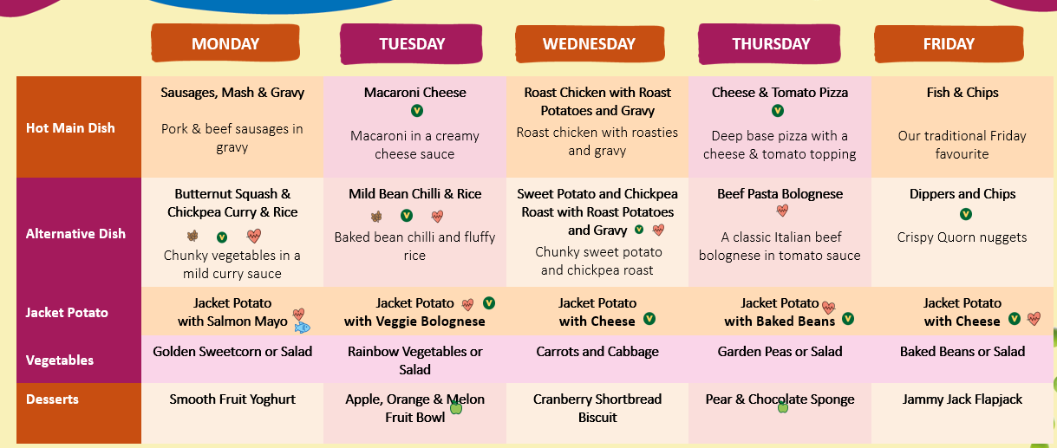
WEEK TWO w/c 9th January 2023
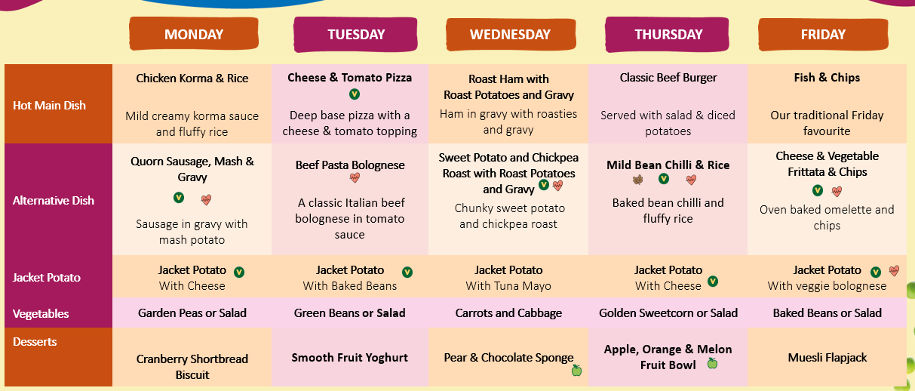
WEEK THREE w/c 16th January 2023
