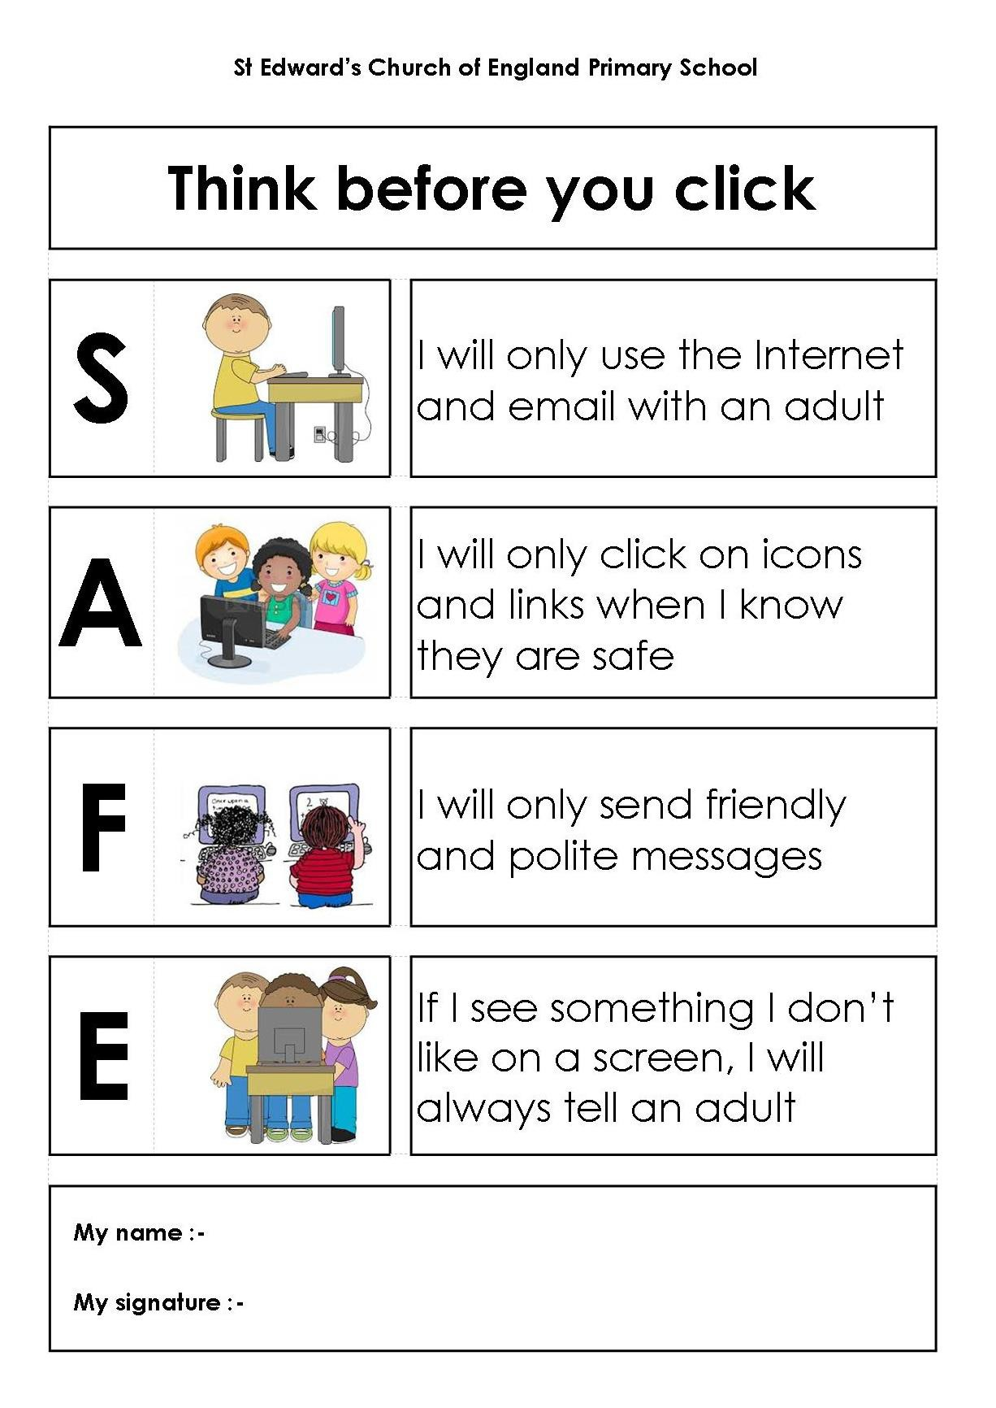

**I have discussed and have agreed this policy with my child.**

**Name of Child: ____________________________**

**Parent Signature: ____________________________**

**Date: ____________________________**

**If I see something online that I don’t like I will tell an adult I trust.**

**I will be friendly when online.**

**If I’m not sure I will ask an adult first.**

**I will ask permission from an adult before I use an iPad, apps or technology.**

# 

# EYFS Acceptable Use Policy Agreement