WEEK ONE w/c 23rd January 2023
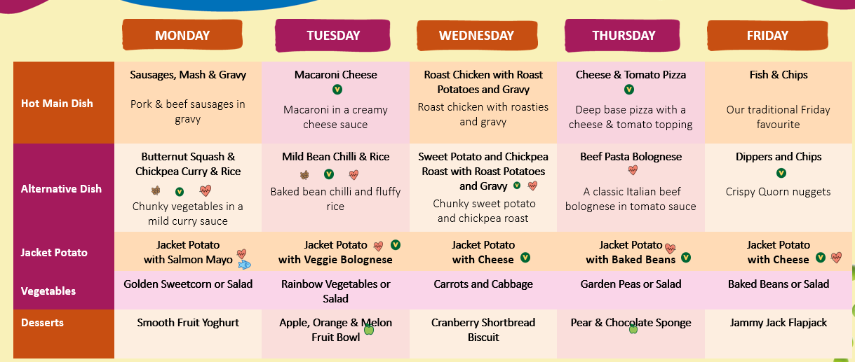
WEEK TWO w/c 30th January 2023
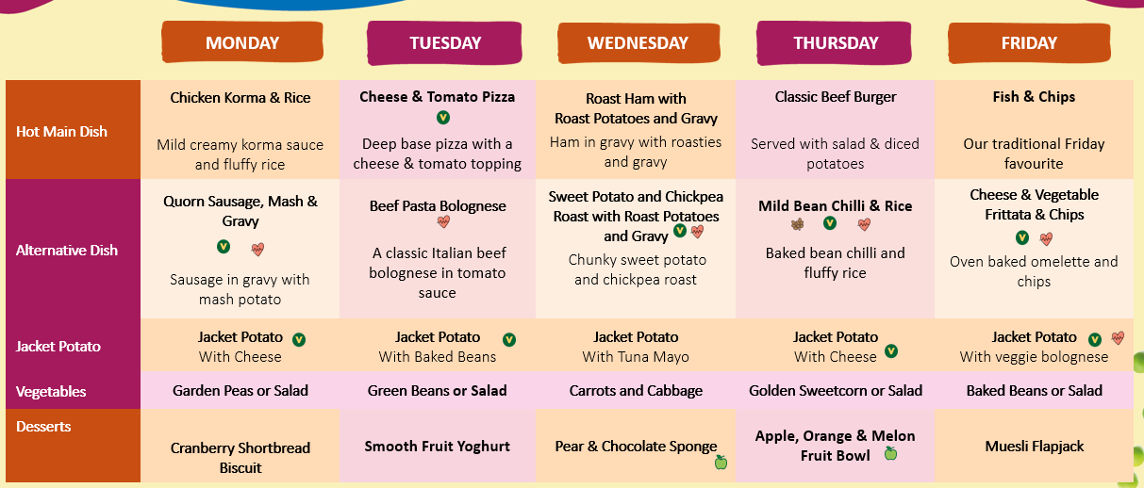
WEEK THREE w/c 6th February 2023
