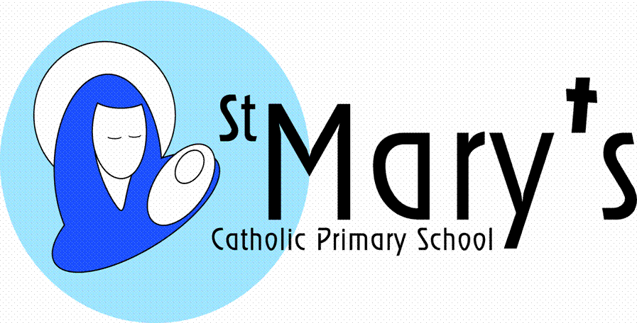**Reception Autumn Term**

**2nd Half**

**Giants and Castles**

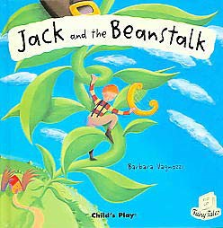

The children will look at Marazion and St. Michael’s Mount. This will fire the imaginations of the children, transporting them into a fairy tale world of castles and giants. They will make an animation about Marazion, using simple puppets to embellish their adventures. Using textiles the children will construct a huge giant for the classroom and explore different materials and textures to decorate him or her. Construction kits and junk modelling materials will be used to make giants’ castles and a bed for their giant. They will look at giant maps to see where Marazion is in Cornwall and they will look at the images of the Giant’s Causeway in Ireland. Through role play they will act out giant stories; especially focusing on Jack and the Beanstalk. They will grow their own bean stalks and with help measure them. The outdoor environment will be utilized to go on giant hunts, make giant letters with squeezy bottles and large paint brushes and also measure giant’s footsteps and play with the foam feet. Giant music will enhance the mood and they will use “In the Hall of the Mountain King” for inspiration.

|  |  |
| --- | --- |
| þÿ  Literacy | During the term, the children will take part in activities relating to the topic of Giants and Castles. The topics will provide opportunities for reading and writing. They will look at non-fiction books and be encouraged to take part in role-play with confidence. The children will bring a book home to share in their reading bag every Monday, Wednesday and Friday. **Please write a comment in their reading record book.**  As we learn the tricky words in phonics we will add these to a key ring. Please practice reading and writing these words. |
| Mathematics | All work in Maths will be differentiated according to each child's previous experience. Using practical activities, the children will use mathematical language while sorting, comparing, ordering, sequencing and counting using everyday objects.  Number rhymes, songs, stories and counting activities will encourage the children to recognise, understand and use numbers.  The children will look at the mathematical areas of counting, shape and space, measures, money, addition and subtraction. |
| þÿ  Knowledge and Understanding of the World | The children will create simple animations using the Ipads. They will work with programmable toys, cameras and the Ipads to support their learning across the curriculum.  The children will work with water, sand, small world and construction sets to explore the concepts of floating and sinking, slope and gradient, and freezing and melting. |
| þÿ  Creative development | The children will work in 2D and 3D, in large and small scale with a particular focus on creating castle models. They will use a variety of materials. They will be introduced to a variety of tuned and untuned percussion instruments, which will be used to produce simple rhythms and accompaniments. |

|  |  |
| --- | --- |
| PSHE | Children will discuss the importance of class and school rules. They will work co-operatively with each other, taking turns with games and sharing equipment. They will take part in role play. |
| Physical Development | In P.E. the children will use a variety of small and large equipment in order to develop throwing, catching, rolling and kicking skills. They will use the bikes and outdoor equipment in the outdoor learning area. |
| Homework | The children will bring a book home on Monday, Wednesday and Friday. Please make a comment in their Reading Record Book. Children should be reading daily and practising the phase 2 phonic sounds and words.  Home learning challenges will be set each week and can be uploaded to their interactive learning diary or brought into school. |
| School Bank | During the year we are involved in many trips and out of school activities. The school bank provides an opportunity for the children to save towards these trips and also develop an awareness of the value of money. Each child has their own bank account and the bank is open on a **Tuesday** morning between 8.30 and 9am for the children to deposit money. I would recommend that the children are introduced to the bank this year with you supporting them in visiting the bank. |
| British Values | Throughout this topic we will be learning about democracy and the monarchy by exploring who lives in a castle. We will learn about our Royal Family and the kings and queens of the past.  We will learn about the British festivals of Bonfire Night and Remembrance Sunday.  Mutual respect and tolerance of other faiths and beliefs is covered through our RE lessons. |
| Safeguarding | Throughout this topic the children will be learning about the role of people who help to keep us safe in our local community. They will learn that castles were built to protect and learn about who protects us now. They will be introduced to rules to keep them safe online and discuss who they can ask for help. |
| Pupil Premium  Cultural Capital | The children will   * Visit a museum * Visit an Art Gallery * Visit a Supermarket   Experience a visit from   * A Police Officer |
| Wellies | Please can all children send in a pair of wellies which will stay in school? We use them in our outdoor area so that the children can go outside whatever the weather! Thank you. |
| Water Bottles | Please can all children have a water bottle every day?  We use these in our daily snack time and outdoor learning sessions as well as during P.E.  During snack time water and milk is also available for the children. |