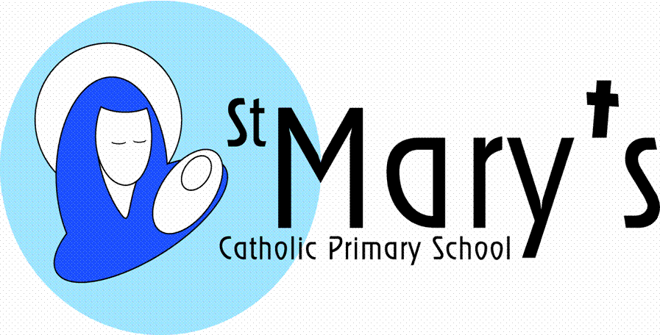
St. Mary’s Catholic Primary School, Falmouth

Acceptable use of Live Streamed Lessons/Meetings Agreement

Live-streamed lessons form an important part of a blended approach to remote learning, providing opportunities for the enhancement of teaching and learning when pupils are not in school.

As with all online activity it is important that all participants observe correct protocols when leading or taking part in live-streamed lessons.

- 1:1 video calls with pupils will not take place.

- Video calls and meetings will only take place during normal school hours.

- Daily screen-time will be reasonable and proportionate for pupils and staff

- Live-streaming of lessons will be used as part of a blended approach to remote learning in which non-screen-time-work has equal value.

- The member of staff will record the length, time, date and attendance for the lesson, and a note of anything of concern that happens in the lesson.

- Parents must be aware that the video call is happening.

- Parents must provide written consent to allow their child to take part in a live streamed lesson. By signing this document the parent is providing consent for his/her child to participate in live-streamed lessons that the parent is aware of.

- Parents have the right to withdraw their consent for their child to take part in remote lessons at any time. This will be done by email to head@st-marys-fal.cornwall.sch.uk

- Staff, children and other members of the household must wear suitable clothing.

- Staff will only use school accounts and devices for live-streaming.

- Staff will only use platforms provided or authorised by the school.

- Devices used by participants, including the member of staff, should be in appropriate areas, for example not in bedrooms; and where possible be against a neutral background.

- Language, behaviour and conduct must be appropriate, and consistent with normal school expectations, including that of any family members in the background.
- At the start of the lesson the member of staff will establish clear ground rules e.g. when and how students can speak. All participants will conform to these.

- Any poor behaviour towards the teacher or other pupils; or misuse of the system will be dealt with under the school’s behaviour/discipline policy

- Parents will not interact with the member of staff during the lesson unless invited to do so by the member of staff. Any concerns will be raised with the member of staff outside the live-streamed lesson

- The member of staff will be sensitive to the needs and feelings of all children including those with SEND.

- Where a virtual lesson consists of participants at school and at home, the member of staff will ensure that appropriate control measures are in place for children in the classroom who should not appear on camera.

- Where a pupil at home should not appear on camera, his/her parents will ensure that his/her camera is turned off and any other appropriate control measures are taken.

- Pupils/parents will not share usernames, passwords or access codes with anybody else.

- Only content agreed by the teacher will be shared in the live-streamed lesson.

- Video calls should have the prior agreement of a member of SLT. Calls will only take place at a pre-arranged time. The times of video calls will be published for parents and pupils in advance

- Entry to a live-streamed lesson will only be through a link for the meeting/videocall distributed by the school. Only people invited by the member of staff are permitted to enter the lesson

- Parents/children/third parties will not share the lesson link with anyone else

- Video calls will be recorded by the school and stored on Google Drive or similar so that the video can be reviewed if the need arises.

- Parents, children and other third parties will not record the lesson by any direct or indirect means without the permission of the teacher/member of staff leading the lesson.

- The member of staff will have control over all participants’ microphones and cameras

- The member of staff will understand how to immediately end the lesson for all participants, and will do so in the event of unsuitable behaviour, language or content being shared/observed.

- The member of staff will remove any pupil from the live-streamed lesson without warning if he/she deems it to be necessary

- Safeguarding concerns will be dealt with through the school’s Safeguarding Policy and procedures

I give consent for my son/daughter to participate in live-streamed lessons in accordance with the above protocols

Signed: ………………………….. (Parent) Date: ………….

Pupil’s name: …………………… Class: ……………….

Or for staff:

I have read and understand the above protocols for use of live-streamed lessons

Signed: …………………………..

