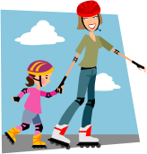  PSHE | The children will explore issues of racism, bullying and conflict resolution in relation to World War II. They will also use the opportunity to challenge stereotypes from other countries, including looking at refugees and prejudice in Europe today, discussing racism and conflict resolution.
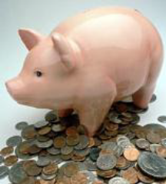  Economic Wellbeing | To use knowledge of diet and healthy eating to design, make and cost a cereal bar:  - To carry out market research.  - To promote their cereal bar  - To cost out the ingredients  - To work out costings of their cereal bars
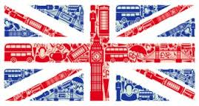  British Values | Children are encouraged to show respect for and an appreciation of other cultures through their learning about other countries. They will also develop their understanding of prejudice through learning about the refugee crisis.  Mutual respect and tolerance of other faiths and beliefs is covered through our RE lessons.
Cultural Capital | During this topic, the children will write and deliver speeches. They will also spend time learning about growth mindset and how to learn from failure in class assemblies.
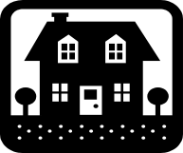  Homework | Friday homework to be returned the following Friday.  Homework related to  Maths, literacy and /or topic.  Weekly spellings.  Daily reading.

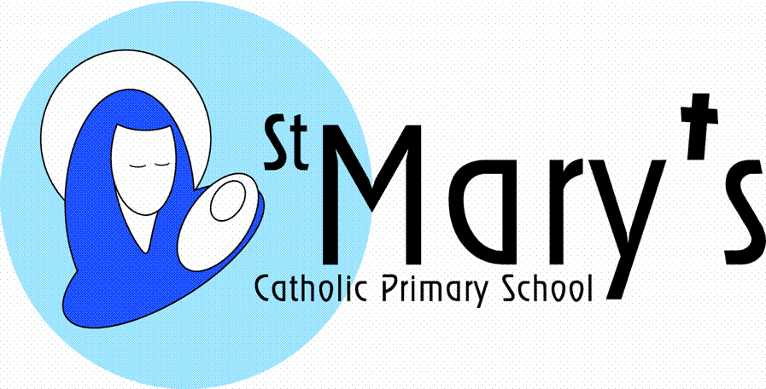
Year 5
Spring Term

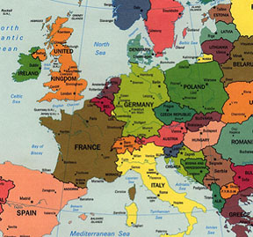

Countries, capital cities, mountains, rivers, flags, culture, landmarks, languages and transport – all of these and many more will be covered in this whistle stop tour – aimed to give the children an broad and substantial knowledge of their continent. They will use their facts to create a useful database of key information. They will also use spreadsheets to plan journeys and calculate travel costs from one country to another. In addition the children will discover the key countries and their actions during World War II and this will lead them to consider the impact of World War II on the daily lives of the people at the time and on their lives today. Children will also look at issues of equality and prejudice, learning about life as a refugee and the current refugee crisis in Europe.

  Literacy | Children will use their European country research to write and perform a presentation, they will study traditional European stories (Grimm’s Fairytales), creating their own silent film version of the stories, then telling their own Grimm’s style tale. They will study persuasive writing and scripts for advertising and create an advert for their European countries (this links with economic well-being work). Finally, they will learn about the life of refugee children, writing diary entries and recounts, as well as writing persuasive letters to our local MP.
  Maths | Every term the children will cover a variety of maths objectives related to five main areas:  Counting, partitioning and calculating  Securing number facts and understanding shape  Handling data and measures  Calculating and measuring  Reasoning and applying mathematical ideas.
  Science | Children will look at all the modes of transport for crossing the continent; air, boat, train, car, bicycle and discuss all of these in relation to forces and friction. In this way the children should cover all types of forces, friction, and air and water resistance. They will also explore balanced and unbalanced forces. In addition the children will look at the wartime diet. They will also compare the diets of European countries and establish which country has the healthiest diet, before exploring the effect of a wartime diet on the health of children, including their teeth.  The children will also use this topic to look at light and dark – understanding the role of European scientists in developing new theories. They will discover key facts about the Earth and space, Sun and Moon, day and night and light and shadows. They will also look at reflective, transparent, translucent and opaque materials.
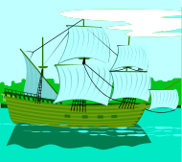  History | This topic covers a brief history of World War II in Europe and in particular looks at its effect on the everyday lives of the people, especially in relation to rationing, wartime evacuees and host families. They will also look at how Europe changed after the war time period, creating the continent we have today.
  Geography | Location, location, location! The children will discover facts and figures on all key geographical aspects for all of the main European countries. This is purely based on independent research done in the classroom and at home. The children each choose a European country with a remit to produce a detailed presentation on that country.
  Art | Children will study an artist from the country of their choice. They will study the artists’ style and try to adopt it. They will use this style for a new piece of work focused on their European country.
  DT | The children will look at traditional hats from a range of European countries and evaluate their purpose. They will then design and make a hat that represents a country of the United Kingdom or another European country of their choice.
  ICT | The children will be compiling databases of key facts of all of the European countries studies. They will also be constructing costing spreadsheets to plan journeys, trips and accommodation from country to country across Europe. They will also create silent films, adverts and soundtracks using a range of apps. Throughout the topic digital literacy (e-safety) skills will be developed.
  Music | Children will study the use of music in silent films and use garage band to compose and perform their own musical score to accompany their silent film.

