Dear Parents

ALLERGY, ASTHMA & DIETARY REQUIREMENTS

You will be pleased to know we have robust policies in place if your child suffers from asthma, has an allergy or has any specific dietary requirements.

A school care plan is available for you to document your child’s requirements however mild or severe their symptoms. Please note we do not store our own school emergency asthma inhaler, a current prescription must be provided by parents.
Should your child need medicine to be stored in school we have secure facilities to do so. Medicine can be stored safely and securely both at room temperature and in a fridge.

If you require medicine to be stored in school, please contact the school office who will give you the appropriate form.

Kind Regards

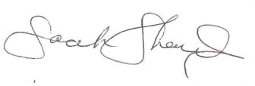

Mrs S Shailes

_________________________________________________________________________________________

Please tick below if you would like a care plan:-

I would like an asthma care plan

I would like a dietary requirements care plan

I would like an allergy care plan

Child’s Name____________________________ Class_____________________________

Date ____________________________

