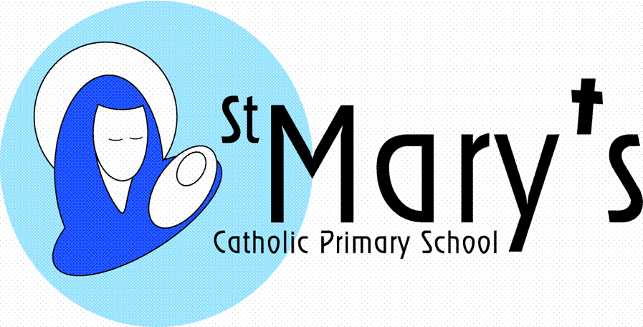
Year 4
Summer Term 1st half
From the Stone Age to the Iron Age
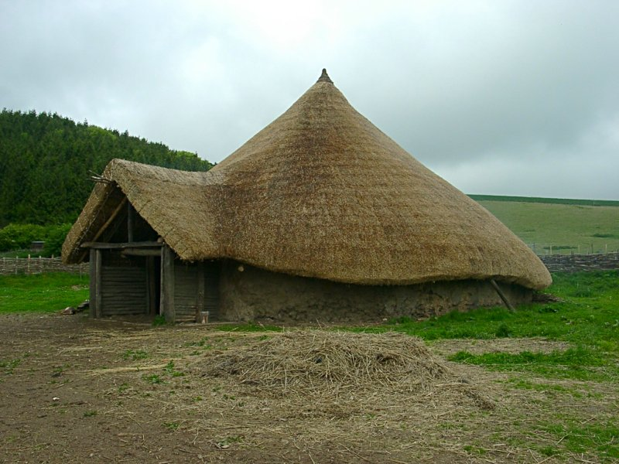

A journey back in time will allow the children to explore this influential period of history. They will be constructing models of Stone Age, Bronze Age and an Iron Age hut, making Iron Age style clay pots, visiting Iron Age fortifications and studying early settlements. They will use their studies to consider the importance of different natural materials and the importance today of recycling to preserve our natural resources.

  Literacy | Using Stig of the Dump as an inspiration for writing the children will look at stories that raise dilemmas and issues. They children will also be writing explanation texts about Iron Age sites, Iron Age inventions and Iron Age life.
  Maths | Every term the children will cover a variety of maths objectives related to five main areas:  Counting, partitioning and calculating  Securing number facts and understanding shape  Handling data and measures  Calculating and measuring  Reasoning and applying mathematical ideas.
  Science | The children will use this topic to look at a huge variety of materials, starting with those that were crucial to life in the Iron Age. They will investigate material properties in relation to uses and will look of ways of changing materials into different forms, particularly by heating and cooling. They will also conduct experiments relating to the best types of material to make roundhouses – a DT project.
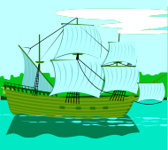  History | The children will be exploring historical Iron Age sites. They will become history detectives and use evidence and artifacts to piece together an overview of what everyday life must have been like in the Iron Age. They will visit Chysauster Iron Age Settlement.
  Art | The children will make Iron Age clay pots with Neolithic designs scratched onto the surface and Stone Age cave paintings.
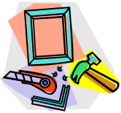  DT | After their studies of materials the children will use a range of materials to produce dwellings from the Stone, Bronze and Iron Age, considering what materials are best suited and why.
  ICT | The children will be using an i-pad animation to model and film their own Iron Age village. They will use the internet to carry out their initial research.  Throughout the topic digital literacy (e-safety) skills will be developed.
  Music | The children will continue to learn to play their brass instruments, musical notation and symbols. They will prepare for a performance at the end of the term.
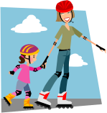  PSHE | This topic enables the children to engage in the current topical debate of recycling.
  Homework | Children will be given one piece of literacy and one piece of maths homework on a Friday which should be handed in the following Friday. In addition they will also be given spellings on a Monday. Homework will relate to children’s learning that day or week. They will be expected to read at home, either to an adult or silently every day. They will be required to know their times tables by the end of this school year.
British Values   | The children will learn about the rule of law and choosing between right and wrong through their story writing when considering the issue and dilemma.
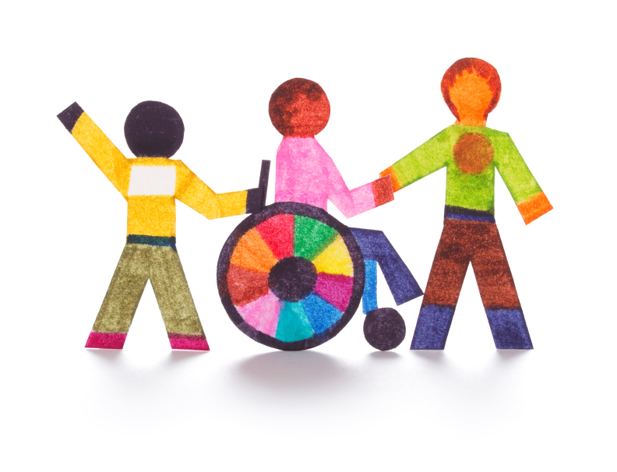

Safeguarding
Pupil Premium    Cultural Capital | The children will;  - Visit the historical sites of Chysauster, an Iron Age Settlement & Lanhydrock  - Visit Truro Museum  - Gardening in the Community

