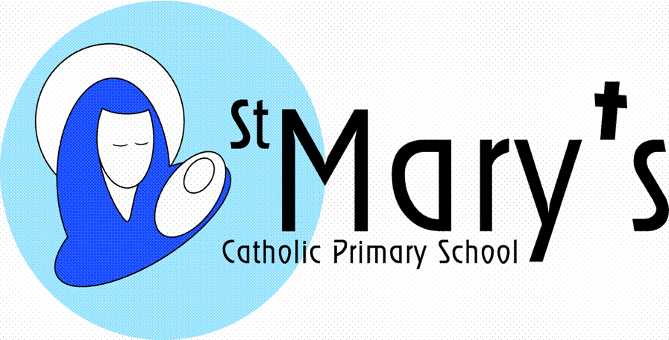
Year 4
Autumn Term

Who Were the Tudors and the Victorians?
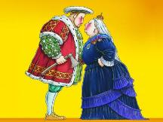

This topic aims to allow our children to explore the local coastline, to look how settlements have built up around the port of Falmouth and to look into the history of Falmouth as a port. The main focus will be on the Tudor explorers looking at life in Falmouth in Tudor times by visiting Pendennis Castle. Trips to the Maritime Museum will allow the children to get an overview of different types of boat, how they have developed through history and how Falmouth as a settlement developed through Tudor and Victorian times. There will be a focus on lighthouses and the children will construct one for themselves. Their science work includes sun, moon and earth and how the moon affects the tides.

  Literacy | This topic, with its focus on the Tudors, has great opportunities for drama and historical fiction. They look at Treasure Island and Treasure Planet and write their own playscript versions of these They will look at the exciting and dangerous lives of the Tudor explorers and produce newspaper reports and recounts of key events. They will use information texts for much of their research and produce their own information texts on their studies. From their trips and workshops to the Museum they write a series of recounts and information writing.
  Maths | Every term the children will cover a variety of maths objectives related to five main areas:  Counting, partitioning and calculating  Securing number facts and understanding shape  Handling data and measures  Calculating and measuring  Reasoning and applying mathematical ideas.
  Science | The children will look at the Earth, Sun and Moon and link their importance to the Tudor explorers and to our tides and coasts today. They will look at materials and their properties in relation to boat construction and sailing and will study the forces of friction, gravity and upthrust. They can plan their own experiments looking at wind resistance and sail shapes. They will also do some work on electrical circuits in order to construct a lighthouse. This includes looking at the properties of light and how it is reflected and refracted.
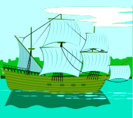  History | The children will be looking at the history of Falmouth as a port with a particular focus on Falmouth in Tudor times. Tudor exploration will be covered here. In the more recent history of Falmouth there will be some coverage of the importance of the Packet Ships.
  Geography | The children will be looking at the development of Falmouth as a port and seeing how the settlement grew. They will also be looking at the coastline to see why Falmouth was such a good location for development and will be looking at environmental factors which affect the coastline. Falmouth past and present is compared by studying local maps and old photos. They will specifically look at past pictures of Falmouth to see how the development of the settlement, in particular docks and tourist industry, has impacted upon the town and have changed since Tudor and through Victorian times.
  Art | The culmination of this topic will involve the printing of a Victorian (William Morris) pattern. In addition the children will look at a whole range of Tudor portraits and how they can be used as a key source of historical information. They will use these as inspiration to paint their own Tudor style portraits.
  DT | The topic will give children opportunities to look at safety at sea. They will link these studies into building a working model of a lighthouse to an inventive and new design.
  ICT | The children will use the Internet to research the Tudors and the Tudor explorers. They will communicate their research through PowerPoints, which will include hyperlinks to websites. They will also use Flowol as a control program to program a flashing sequence for their lighthouses.  Throughout the topic digital literacy (e-safety) skills will be developed.
  Music | The children will listen to the music accompanying the Tudor Pageant Plays. They will try to recreate the Tudor sounds and musical patterns. As Christmas approaches they will look at exploring arrangements to produce a Tudor Christmas composition. This will include Tudor dance.
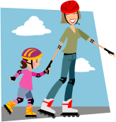  PSHE | Children will discuss safety and pollution issues related to the sea. They will also reflect on what they can do to improve the local coastlines.
  Homework | Children will be given homework once a week. It will be set on a Friday to be handed in the following Tuesday. Homework will relate to children’s learning that day or week. They will be expected to read at home, either to an adult or silently every day. A big focus this term will be learning their times tables.

