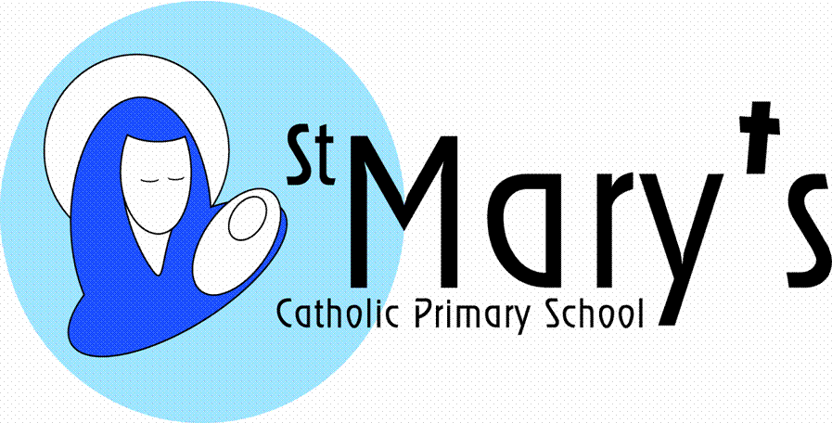
17th May 2019
Dear Parents,
Promotion for Miss Buscombe
I’m writing to inform you that Miss Buscombe has been appointed as Deputy Headteacher at Holy Cross Catholic Primary School in Plymouth. She will take up her new post from September 2019.
Miss Buscombe has taught at St Mary’s for nineteen years and has been an integral part of the team here at St Mary’s. She will be sadly missed and extremely difficult to replace, but I am sure you will join with the staff and governors in wishing her every success in her career promotion to senior leadership.
Yours sincerely
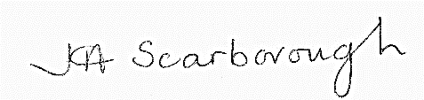

20th May 2019
Dear Parents,
Promotion for Mrs French
I’m writing to inform you that Mrs French has been appointed as Assistant Headteacher at Southerly Point Multi Academy Trust. She will take up her new post from September 2019.
Mrs French has taught at St Mary’s since 2008 and has been an integral part of the team here at St Mary’s. She will be sadly missed and extremely difficult to replace, but I am sure you will join with the staff and governors in wishing her every success in her career promotion to senior leadership.
Yours sincerely
