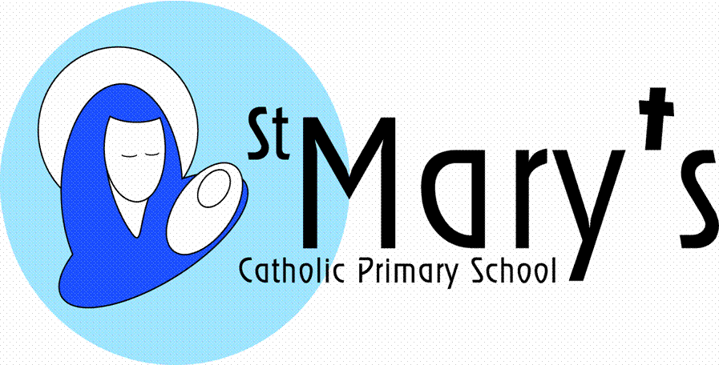

Newsletter Issue 10: 25th January 2019
Dear Parents,
On Sunday 27th January 2019 we will be enrolling the children who will be making their First Holy Communion this year. This will be a whole school celebration and we would like to see as many of our pupils representing the school at the 10:45am Mass at St Mary’s Catholic Church on Killigrew Street. Our pupils will be taking an active part and this invitation is extended to all. The choir will also be taking part, so we hope that as many as possible will come along.
Following our primary school ranking at 249th nationally in the Sunday Times for our 2017 end of Key Stage results, we are once again delighted that St Mary’s School is ranked second overall in Cornwall for our 2018 end of Key Stage 2 data according to Cornwall Live. There are over 235 primary schools in total in Cornwall, we’re happy with second place so well done to staff and pupils alike.
Well done to the two teams of Year 6 pupils who attended the Youth Speaks competition run by the Rotary Club on Tuesday. The topic that Maxwell (Speaker), Dylan (Chairperson) and Rosie (Vote of Thanks) chose was ‘Ocean Pollution’ and Evan (Speaker), Josh (Chairperson) and Chloe (Vote of Thanks) chose the subject of ‘Dogs V Cats’. Evan, Josh and Chloe were lucky enough to be placed 3rd, but they all did exceptionally well and we’re really proud of them.
Warm regards Jacqui Scarborough

Are you able to help?
We’re looking for volunteers;
- to hear readers in class
- to help in the library
- on the ‘Walking Bus’
- to help with supervision on the swimming coach on a Friday
- to help with transportation to sporting events

DIARY DATES
January
27th Enrolment Mass - St Mary’s Catholic Church @ 10.45am
31st Assembly - Mary’s Meals
February
1st Non-Uniform day for the Blue House only
4th Class 1 hearing re-tests
11th Assembly and workshops - NSPCC
12th Cross-Country finals
18th-22nd HALF TERM (Go Active Holiday Club on Thursday 21st Feb)
March
6th Ash Wednesday Mass
7th Class 3 Fairtrade Coffee Morning from 9.45-11.15am
14th Paint the Town Yellow – Falmouth Spring Festival-Class 2
20th Penitential Service
28th Songfest for Class 6 @ Falmouth Methodist Church
27-28th Class 5 residential to Carnyorth

SPORTING NEWS
The Cross Country races were held today at Falmouth School. Over 66 of our pupils took part from Years 4-6 and it proved to be a fantastic afternoon. As soon as the results have been collated, the children will be informed. The next round is on 12th February.
Well done to all who took part and a big thankyou to the helpers who assisted with walking up to Falmouth School and back to St Mary’s after the event.
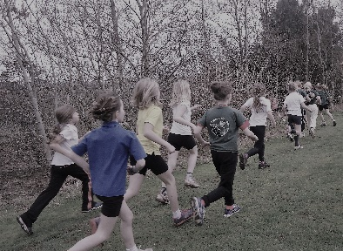
WELL DONE
The ‘Blue House’ gained the most house points during the second half of the Autumn term, so have been rewarded with a Non-Uniform Day on Friday 1st February.
FOSMs
A huge thank you to our hardworking FOSMs who have worked tirelessly and raised an enormous amount of money for our school.
Christmas Fayre £1,977.66
Christmas Cards £238.70
Bags for school £232
Thank you also to Mrs Taylor and Mr Bordeaux from Lloyds who matched funded £500 each!

EMERGENCY SCHOOL CLOSURE PROCEDURES
A reminder of the emergency school closure procedure is as follows. We strongly recommend that you listen to updates on BBC Radio Cornwall, Pirate FM or Heart FM for up to date information on school closures which will also be posted on the radio stations websites. We will endeavour to contact all parents via the Schoolcomms system. This system sends a message to parent’s mobile phones. If you have recently changed your mobile number, please inform the school office. Alternatively, log on to our school website for the latest details about emergency closure. www.st-marys-fal.cornwall.sch.uk
In the event for example of heavy snow during the school day, you the parents are in the best position to assess the road conditions etc. where you live. If you need to collect your child early then this is acceptable. The school will remain open until all pupils have been collected.
COMMUNITY EVENTS
MESSY CHURCH is an all-age family gathering with craft, games, songs, story and food, not like conventional church; that is partly why it’s called “Messy”. There is plenty of space for the energetic to run around, and we do not expect anyone to sit quietly when they are not in the mood.
The next gathering will be on SATURDAY 8th February between 9.30 and 11.00 at All Saints Church, Killigrew Street, Falmouth.
We will start at 9.30 with a healthy and delicious breakfast and then there will be games and activities, followed by an interactive story and songs. Everyone is welcome and we would be delighted to see you. All children must be accompanied by an adult please. Messy Church is free, but donations are very welcome.
For more information see www.messychurch.org.uk or find us on Facebook.com/Falmouth Messy Church .

BACON BUTTY SUNDAY

The Apostleship of the Sea will be providing their popular winter warmer on Sunday 27th January, after the morning Mass. To be held in the church hall at St Mary’s Catholic Church.

Proceeds go to providing items for seafarers who visit the Port of Falmouth. Still only £2.50

Please note that signposting to any activities/services by St Mary’s School does not constitute an endorsement or recommendation. It is recommended that parents/carers make their own enquiries to satisfy themselves as to the suitability of these. Under no circumstances will either St Mary’s School or Plymouth CAST accept any responsibility or liability for any such activity/service.
SAFER INTERNET DAY
The internet is a wonderful place that offers so many opportunities for children to learn, connect and play. As the internet is always changing, being able to keep up to date with your child’s internet use can sometimes feel overwhelming, especially if you feel that your child may know more about technology than you do.
Safer Internet Day 2019 will be celebrated globally on Tuesday 5th February 2019 with the slogan “Our internet, our choice-understanding consent in a digital world”, the day provides a fantastic opportunity to engage with children about their digital lives. It provides a brilliant and fun way to discuss and explore online safety with your child. By being part of something bigger, talking about how to stay safe online can be fun, engaging and accessible! Children in all classes will be taking part in assemblies and learning about this vital area of online safety so please do ask your child about their learning. Further information about online safety for parents can be found on our school website or at https://www.saferinternet.org.uk/safer-internet-day/safer-internet-day-2019/education-packs/activities-parents-and-carers
The SIDTV videos provide a great way to start a discussion with children about how the internet makes them feel and what tips they have about staying safe. The videos can be watched on the UK Safer Internet Centre website or on YouTube. www.saferinternet.org.uk/sid-tv

