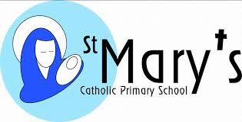
Key Stage 2 Results 2019

Measure | School | National
% of pupils who have achieved the EXPECTED standard in READING, WRITING and MATHS (combined) | 78% | 64%
% of pupils who have achieved the EXPECTED standard in READING | 88% | 73%
% of pupils who have achieved the EXPECTED STANDARD in WRITING | 81% | 78%
% of pupils who have achieved the EXPECTED STANDARD in MATHS | 84% | 79%
% of pupils who have achieved the EXPECTED STANDARD in PUNCUTATION, GRAMMAR AND SPELLING | 81% | 78%
% of pupils who have achieved the HIGHER STANDARD in READING, WRITING AND MATHS (combined) | 16% | 10%
% of pupils who have achieved the HIGHER STANDARD in READING (Greater Depth) | 44% | 27%
% of pupils who have achieved the HIGHER STANDARD in WRITING (Greater Depth) | 28% | 20%
% of pupils who have achieved the HIGHER STANDARD in MATHS (Greater Depth) | 25% | 27%
% of pupils who have achieved the HIGHER STANDARD in PUNCTUATION, GRAMMAR AND SPELLING (Greater Depth) | 53% | 36%
Average scaled score in READING | 107 | 104
Average scaled score in MATHS | 106 | 105
Progress Measures 2019

Average progress that pupils made in READING between KS1 and KS2 | 3.26 | 0
Average progress that pupils made in WRITING between KS1 and KS2 | 1.52 | 0
Average progress that pupils made in MATHS between KS1 and KS2 | 1.39 | 0

