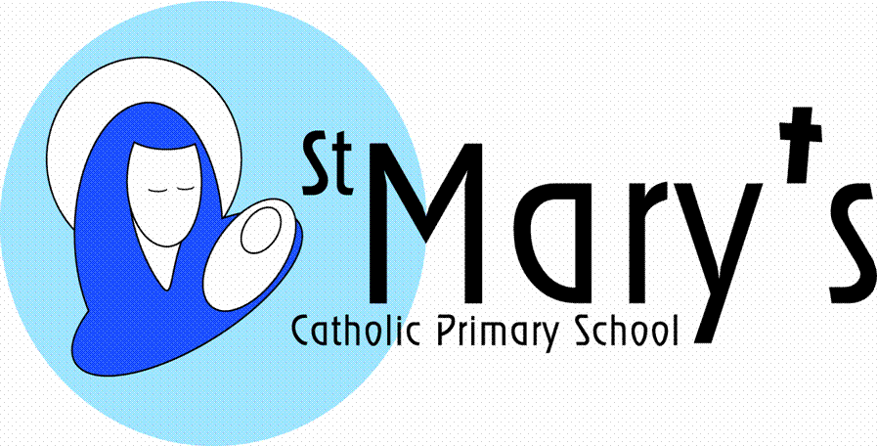

**Year 2**

**Spring Term 2nd half**

**Health**

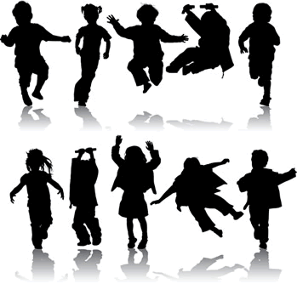

Through this topic the children will find out all about their bodies and how to keep themselves fit and healthy. They will meet with health professionals to get a better understanding of their role in keeping healthy and they will study nurses of the past – Florence Nightingale and Mary Seacole. They will compare and contrast medical treatments past and present and use photo stories to represent their findings. Linked to this topic is a wonderful story project about the implications of a sick day for zoo keeper Amos McGee.

|  |  |
| --- | --- |
| Literacy | They will use the theme of being healthy to write non-chronological reports on ways to stay healthy. They will also use stories with familiar settings to learn about health and being healthy. Using the impetus of “A sick day for Amos McGee” children will story tell and write stories about the unfortunate zoo keeper and the characters that his sick day affects. |
| Maths | Every term the children will cover a variety of Maths objectives related to five main areas:  Counting, partitioning and calculating  Securing number facts and understanding shape  Handling data and measures  Calculating and measuring  Reasoning and applying mathematical ideas. |
| Science | The science in this topic will relate to the body and keeping the body healthy. They will study life processes and their own body parts. Observation and measurements will be important as they compare and contrast body parts e.g. shoe size, hand span, eye colour. They will also study the role of drugs as medicines and how they are used to keep us healthy. They will conduct experiments on their own fitness and make simple measures of time and pulse rate and observations on the effects of exercise. They will also explore experiments using all of their senses. |
| History | The history in this topic will relate to two famous nurses – Florence Nightingale and Mary Seacole. The children will research aspects of the Crimean War and research facts about the life and times of these nurses. They will compare and contrast their lives with those of medical professionals today and look at developments in health and medicine across the centuries. |
| Geography | The children will use maps to identify the location of the Crimean war. They will also find out a few key facts about the country of Jamaica to give them an idea of the life of Mary Seacole. |
| Art | Fruit will be the main focus of the artwork in this topic. The children will focus on line and tone as they produce accurate drawings of different fruits. They will then create and decorate their own papier mache fruits. |
| DT | The DT in this topic is related to food. The children will be asked to design, make and evaluate smoothies. |
| ICT | The children will use ICT for all aspects of this topic. They will be using the internet to carry out research on Florence Nightingale and Mary Seacole. They will then use Book Creator to retell their life stories. In their promotions of healthy eating the children will use ICT to compose jingles using Garage Band for their healthy eating advertisements.  Throughout the topic digital literacy (e-safety) skills will be developed. |
| Music | The children will use musical instruments and ICT to produce advertising jingles to promote healthy eating. They will be particularly experimenting with duration of sounds to enhance aspects of their jingles. |
| PSHE | The children will think about their own personal health and the choices that they can make to influence their health and fitness. They will also consider aspects of emotional health and consider their personal triggers for moods and feelings. Through their history studies they will consider the personal hardship that nurses like Florence Nightingale underwent and also consider the positive role that health professionals play in today’s society. |
| Homework | Daily reading with an adult.  Homework will be based on Literacy, Numeracy or another curriculum subject. Homework is handed out on **Mondays** and collected on **Fridays**. |
| Economic Well Being and Financial Capability | Through this topic the children will find out all about their bodies and how to keep themselves fit and healthy through making the right choices enable them to be ready for work. . The coastguard and a nurse will visit school enabling them to get a better understanding of their role in keeping us safe and healthy and finding out details of their jobs. They also get an idea of the world of marketing through watching promotional adverts for food and making their own for their sandwiches. |
| Image result for british values  British Values | This topic will be supported by visits from health professionals. We will actively promote and model democracy through developing the children’s knowledge of and promoting respect for these public institutions.  The children will develop an awareness of individual liberty when exploring female rights linked to their work about Mary Seacole and Florence Nightingale. Through an understanding of mutual respect, children will learn that it is ok to be different. Tolerance of other faiths and beliefs is covered through our RE lessons. |
| Image result for safeguarding  Safeguarding | The children will learn the importance of medicines and how these need to be used carefully and correctly and only with adult supervision. |
| Pupil Premium  http://t0.gstatic.com/images?q=tbn:ANd9GcS485BMyyUv-YOypkRVcazMv-eh-2E5izjVKFGXFcZcLJKQs6asIIoEWd0:p2cdn4static.sharpschool.com/UserFiles/Servers/Server_2931974/Image/NHES/Counseling/happy_kids.jpg  Cultural Capital | Children will:   * “Paint the town yellow”, contributing to the town’s Spring flower festival * Visit a library and an art gallery * Travel on a train |