NEWSLETTER ISSUE 5: 9th November 2018
Dear Parents,
I hope you enjoyed the half term break and welcome back to what will be a very busy half term! This is a magical time to be in school as the countdown to Christmas begins! Rehearsals have begun for the Christmas plays and the excitement is tangible! The School Choir is also preparing for their many performances in the local community.
This week all classes have been focusing on the centenary of Armistice Day and the end of World War 1. They’ve been extremely busy designing and making poppies as symbols of remembrance with some classes working with their buddies. These will be displayed in the hall and main corridor next week. The school is also supporting the Royal British Legion and items such as poppies, erasers, pencils rulers and wrist bands are on sale.
We’re looking forward to welcoming you to the forthcoming parent consultation meetings later this month, when you can discuss your child’s/rens progress to date. Details will be sent out next week.
Our first termly parish school Mass celebrating ‘Christ the King’ takes place on Sunday 25th November at 10:45am. The Parish has decided to have a second collection for the school and to show our appreciation, it would fantastic if as many of our pupils are in attendance as possible. So please do make every effort to come along, as the children from St Mary’s will be taking an active part in this celebration.
Finally, please don’t hesitate to speak to me at the gate in the mornings if you have any queries, concerns or just for a chat!
Warm regards
Jacqui Scarborough

DIARY DATES
November
12th Start of National Anti Bullying Week
13th Y2 Cinema visit @ The Poly
14th Netball League match @ Falmouth School @ 3.45pm
15th Education Welfare Officer’s Visit
Y5/Y6 Cinema Visit @ The Poly
16th School Jazz band Session @ Falmouth School
FOSM’s Dress Down Day & Christmas Hamper donations (morning)
20th Parent Consultation Meetings from 3:30pm
22nd Parent Consultation Meetings from 3:30pm
23rd FOSM’s Dress Down day & Christmas Tombola Collection
25th ‘Christ the King’ Parish School Mass @ St Mary’s Church, Killigrew @ 10:45am
26th Test Week for Years 1 to 6
30th FOSMs ‘Bags to School’ collection at 9am
FPSMs Dress Down Day & Christmas Bottles donation

December
2nd Christmas Tree Festival at Princess Pavilion with St Mary’s School Choir
W/B 3rd Prayer Space
4th First Holy Communion Meeting for parents @ 6:30pm in the Presbytery
7th FOSM’s Christmassy Clothes Dress Down Day & Cake donations
Choir to visit Age Concern & Stroke Club (afternoon)
Christmas Fayre after school
No swimming lessons for Yrs 5 & 6
12th Christmas Dinner
14th Swimming Gala
Last swimming lesson for Yrs 5 & 6 – fun session
Choir Performance with Truro Male Voice Choir @ 6:00pm
16th Christingle Service @ St Mary’s Church, Killigrew Street
17th Reception Class Christmas Performance @ 2:00pm
18th Classes 1 & 2’s Christmas Performances @ 1:30pm and 6:30pm
19th Classes 3 & 4’s Christmas Performances @ 1:30pm and 6:30pm
20th End of Term Mass @ 9:15am
Christmas Parties

NATIONAL ANTI BULLYING WEEK 12th NOVEMBER 2018
The theme for this week is ‘’Choose Respect’. All classes are invited to wear odd socks on Monday 12th November to mark the beginning of this important week. Our Anti Bullying Policy, which is available on our school website www.st-marys-fal.cornwall.sch.uk , outlines our procedure in the event, after investigation of any bullying incident.

ONLINE SAFETY INFORMATION SESSION 15TH NOVEMBER AT 3:30PM
Please note this parent session publicised in the last newsletter has been postponed to the Spring Term.

ADMISSIONS
If you have a child born between 1 September 2014 and 31st August 2015 then you will need to apply for your child’s Reception 2019 place by Tuesday 15th January. For information and guidance please visit www.cornwall.gov.uk/admissions where you will also find the application form. Telephone: 0300 1234 101
Email: schooladmissions@cornwallgov.uk. For any help with your application, please contact the Family Information Service on 0800 587 8191. A St Mary’s Catholic Primary School supplementary admission form will also need to be completed and returned to the school office. The National Offer date is 16 April 2019, this is when you will be notified of your allocation.

WALKING BUS
The building work taking place along Bickland Water Road is yet again having an impact outside our school. Why not use the ‘Walking Bus’ to relieve the congestion and give your child/ren a healthy start to the day?
The ‘Walking Bus’ leaves at 8:30am from the Co-Op to walk the short distance to school. This relieves congestion in the cul de sac and also gives a healthy start to the day for the children. To enroll, please collect a form from the school office.
Many thanks to all those parents who help with supervision on the bus in the mornings.
If you are able to assist, even if only for one morning a week, please let us know.
SPORTING NEWS
Competitive League Training League
St Mary’s 1- Marlborough 0 St Mary’s 0- Marlborough 3

FOSMS
Our Christmas Fayre takes place on 7th December after school and our hard working FOSMs are planning and organising this event. Santa will also be visiting on this date. If you can help in any way please do let them know, as many hands make light work! Any goods for the stalls or raffle and hamper items are gratefully received. Please do come along to support this event which raises much needed additional funds for our school. (Further details available below)
Dress Down Days for Donations
Friday 16th November – Hampers
Friday 23rd November – Tombola
Friday 30th November – Bottles
Friday 7th December – Cakes (Christmas jumper/outfit dress down)
Other donations such as books/toys/teddies can be brought it any week.

A BIG THANK YOU TO PARENTS
A huge ‘thank you’ to all those parents who have kindly given us good quality fiction books for our school library, especially to Mrs Webb, Mrs Osyka, Mrs Shailes and Mrs Price.
Also a big thanks to Mr Tuffery for kindly offering to service our stage lighting in preparation for the Christmas Plays.

WELL DONE
Congratulations to Maisy, Milly and Charlie who took part in a music competition in Torquay at the weekend. All three children are members of St. Keverne Youth Band and won a shield for their efforts.
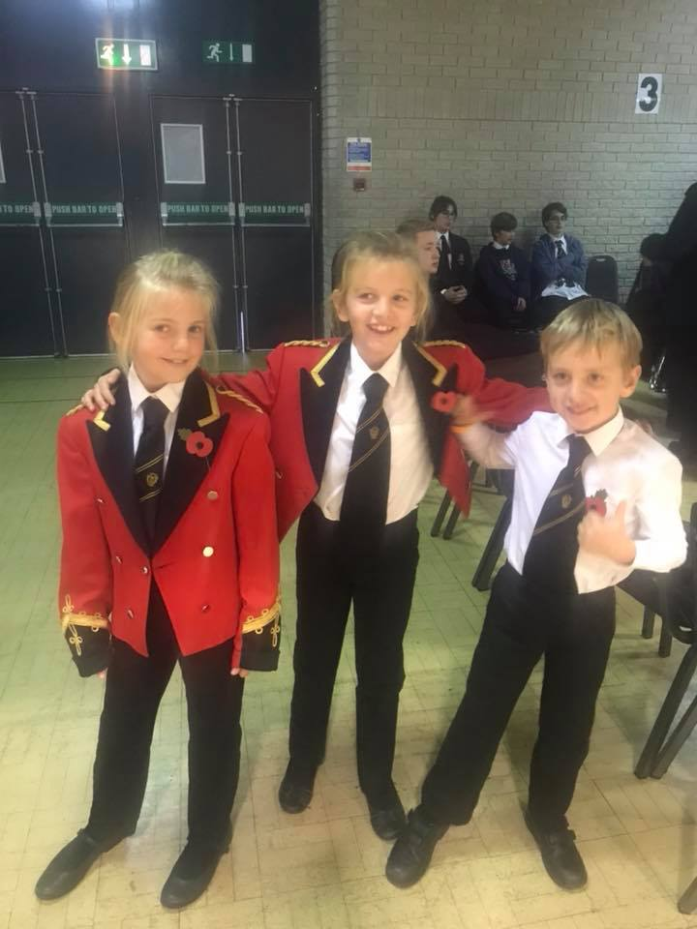
We would love to hear about your child’s achievements outside of school, please contact Mrs Chapman on: schapman@st-marys-fal.cornwall.sch.uk

REMEMBRANCE WALK
Our pupils have been working hard to produce a wonderful Remembrance Walk in school.

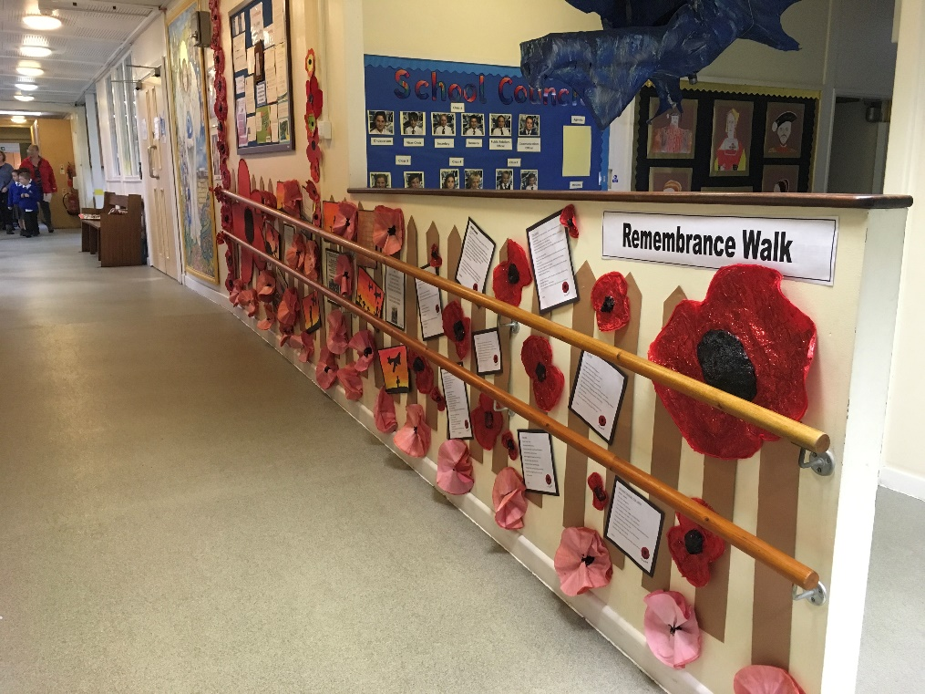
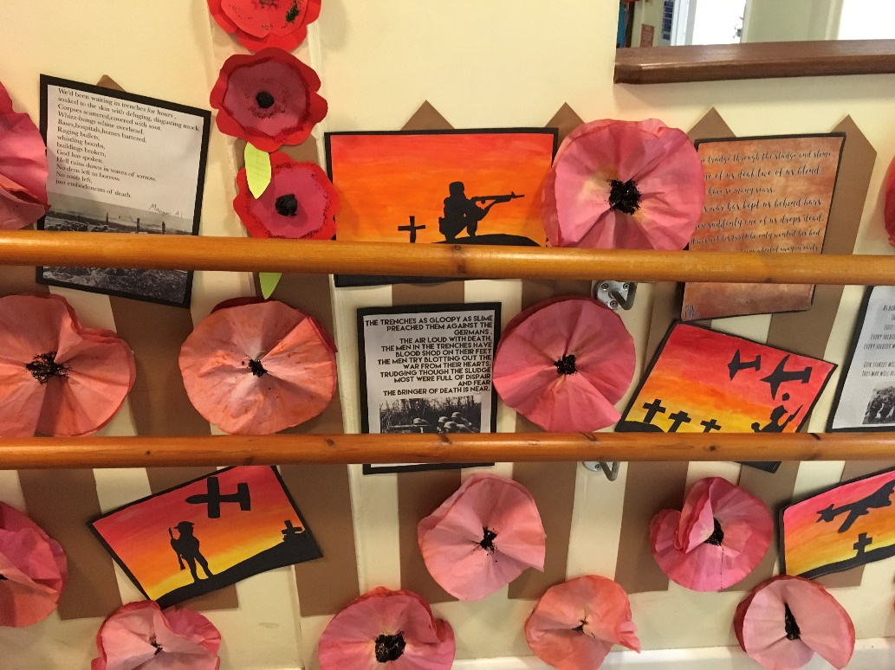

BAG2SCHOOL – FRIDAY 30TH NOVEMBER.
If you’re having a clear out before Xmas, please don’t forget the ‘Bags to School’ which raises really important funds for our school.

FIRST HOLY COMMUNION
There will be a meeting for parents only on Tuesday 4th December at 6:30pm in the Presbytery, Killigrew Street, Falmouth. The sessions for children will begin on Tuesday 8th January 2019 and the celebration of First Holy Communion will take place on Sunday 19th May 2019 at the 10:45am Mass.

ANTI-BULLYING WEEK
The theme for Anti-Bullying Week 2018 is: ‘Choose Respect’ which runs from 12th - 16th November
On Monday 12th November we would like all the children to come to school wearing odd socks to mark the start of anti-bullying week. It’s an opportunity for our children to express themselves and celebrate their individuality and what makes us all unique!
The aims of this week are to support our children and young people to understand:
- The definition of respect
- That bullying is a behaviour choice
- That we can respectfully disagree with each other i.e. we don’t have to be best friends or always agree with each other but we do have to respect each other oth face to face and online
- That we all need to choose to respect each other both face to face and online

CODE CLUB
Falmouth Art Gallery will be running a free Code Club from 1:00-2:00pm in Falmouth Library on a fortnightly basis from 17th November which is open to all KS2 children. If you would like to find out more contact: Learning@falmouthartgallery.com or just drop into the library.

MESSY CHURCH
The next family gathering will be on Saturday 10th November between 9:30 and 11:00 at All Saints Church, Killigrew Street, Falmouth. It starts at 9:30am with breakfast, followed by games and activities, a story and songs. Everyone is welcome, but all children must be accompanied by an adult. Messy Church is free, but donations are very welcome.
For more information see www.messychurch.org.uk or find them on Facebook.com/Falmouth Messy Church.

Please note that signposting to any activities/services by St Mary’s School does not constitute an endorsement or recommendation. It is recommended that parents/carers make their own enquiries to satisfy themselves as to the suitability of these. Under no circumstances will either St Mary’s School or Plymouth CAST accept any responsibility or liability for any such activity/service.

