St. Mary’s Pupil premium Strategy Statement 2018-19

“I was disadvantaged as a child, yet I had the advantage of being in the company of great teachers.”
(A.P.J. Abdul Khan, 11th President of India)

“Every one of our children is carrying something the world is waiting for – it’s just the world hasn’t got it yet,” Sister Judith Russi

The ‘Pupil Premium’ is a government initiative that provides extra funding aimed at pupils from disadvantaged backgrounds. Research shows that pupils from deprived backgrounds underachieve compared to their peers and that there is a strong link between eligibility for free school meals and underachievement. The Pupil Premium is designed to help each school boost the attainment of disadvantaged children and reduce the gap between the highest and the lowest achievers. The government has used pupils’ entitlement to free school meals (FSM) and children looked after by the local authority (CLA) as an indicator for deprivation. The funding is allocated according to the number of pupils on roll who have been eligible for free school meals at any point in the last 6 years (known as ‘Ever6 FSM’), an allocation for each pupil who has been ‘Looked After’ (in care) and a smaller amount for the children of service families.

Principles

- To ensure that teaching and learning opportunities meet the needs of all pupils.
- To ensure that appropriate provision is made for pupils who belong to vulnerable groups, this includes ensuring that the needs of socially disadvantaged pupils are adequately assessed and addressed.
- In making provision for socially disadvantaged pupils, we recognise that not all pupils who receive free school meals will be socially disadvantaged.
- We also recognise that not all pupils who are socially disadvantaged are registered for free school meals. We reserve the right to allocate the Pupil Premium funding to support any pupil, or groups of pupils the schools have legitimately identified as being socially disadvantaged.
- Pupil Premium funding will be allocated following a needs analysis which will identify priority groups or individuals. Limited funding and resources means that not all children receiving free school meals will be in receipt of pupil premium interventions at one time.

- Summary information
Academic Year | 2018-2017 | Total PP budget | £19,800 | Date of most recent PP Review | July 2018
Total number of pupils | 219 | Number of pupils eligible for PP | 24 | Date for next internal review of this strategy | February 2019

FSM | Ever6 | Pupil Premium Plus  (Adoption Premium) | Services
7 | 7 | 4 | 6

Current Academic Year
(Percentages are for each cohort and the totals across the school)

Year Group | Total | FSM | Ever 6 | Services | Adoption Premium
Year 6 | 4 | 0 | 3 | 1 | 0
Year 5 | 4 | 0 | 3 | 1 | 0
Year 4 | 6 | 3 | 1 | 1 | 1
Year 3 | 4 | 2 | 0 | 1 | 1
Year 2 | 2 | 1 | 0 | 1 | 0
Year 1 | 2 | 1 | 0 | 0 | 1
Reception | 2 | 0 | 0 | 1 | 1
Total  Out of whole school  Out of Pupil Premium | 24/11% | 7  3%  29% | 7  3%  29% | 6  2.7%  25% | 4  2%  17%

- Current achievement
End of KS1 & 2 Attainment for: 2018-2019 | Pupils eligible for PP | Pupils not eligible for PP
 |  | School | National
% achieving expected standard or above in reading, writing and maths | 83% | 90%
% achieving expected standard or above in reading | 83% | 97%
% achieving expected standard or above in writing | 83% | 90%
% achieving expected standard or above in maths | 83% | 97%
Progress score in Reading |  | 5.1
Progress score in Mathematics |  | 4.4
Progress score in Writing |  | 2.9
% achieving expected standard or above in reading at KS1 | 75% | 80%
% achieving expected standard or above in writing at KS1 | 75% | 76%
% achieving expected standard or above in maths at KS1 | 100% | 84%

- Barriers to future attainment (for pupils eligible for PP, including high ability)
In-school barriers (issues to be addressed in school, such as poor oral language skills)
Progress in reading of PP children
Oral language skills, EYFS and Key Stage 1
Poor social and emotional resilience
Understanding of language and working memory
External barriers (issues which also require action outside school, such as low attendance rates)
Attendance

- Desired outcomes
 | Desired outcomes and how they will be measured | Success criteria
 | The progress in reading for PP pupils will rise to be in line with the progress of all children.  - Arrow  - 1:Group  - Accelerated Reader | The gap between those pupils in receipt of PP funding and those who are not will be minimised with PP children making at least 5 steps progress.
B. | Children will become more resilient, secure and confident.  - TA support  - TIS  - Meta- cognition- solo taxonomy, growth mind-set | Targeted children will build their resilience and become more secure and confident providing a firm foundation for them to be able to learn. Those pupils supported by the Thrive Practitioner will have increased social and emotional well-being.
C. | Increased attendance for PP pupils.  - EWO  - Rewards  - Newsletter  - Attendance clinic  - Feedback at termly progress meetings  - Feedback/data on annual school report. | Targeted PP pupils with historically low attendance will show better attendance, achieving at least in line with national attendance. Our aim is to continue to sustain the good attendance of all of our PP students.
D. | Quality First Teaching developing growth mind set, the use of P4C and meta-cognition and self- regulated learning.  - Effective questioning.  - Stretching and challenging all pupils including disadvantaged and MA disadvantaged.  - Enabling pupils to develop as learners.  - Reduce gaps in Cultural Capital for all pupils. | All pupils to make at least 5 steps progress and to be able to articulate what it means to be a successful, independent learner.  All pupils to gain life experiences through visits and in school experiences to enhance their learning.

- Planned expenditure
Academic year | 2018/19
The headings below enable schools and the Trust to demonstrate how they are using the pupil premium improve outcomes for Pupil Premium Children. These headings are the same of all Plymouth CAST schools, but can be individualised under the Chosen action/approach column.
a. Additional Teaching Staff
Desired outcome | Chosen action / approach | What is the evidence and rationale for this choice? | How will you ensure it is implemented well? | Staff lead
4a)  The attainment in reading for PP pupils will rise to be in line with the attainment of all children. | PPG (TAs)  Accelerated Reader | This arrangement enables the  teacher to focus exclusively on a  small number of learners, usually on  their own in a separate classroom or working  area. Intensive tuition in small groups is often  provided to support lower attaining learners  or those who are falling behind, but it can  also be used as a more general strategy to  ensure effective progress, or to teach  challenging topics or skills.  Pupils selected are those that do not read at  home or those behind their peers.  Additional  EE Foundation Toolkit Reading  comprehension strategies: +5 mths  Small group tuition: +4mths  Feedback: +8mths  Reading comprehension strategies: +5 mths | Teachers/teaching assistants keep records of who reads every day and their reading progress/AR quizzes. Also, progress discussed at termly pupil progress meetings. | JS/SF
Outcomes:

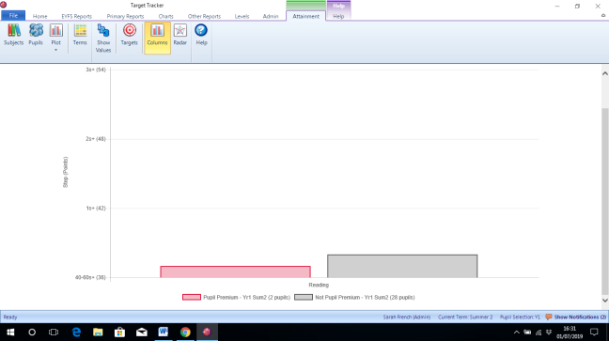
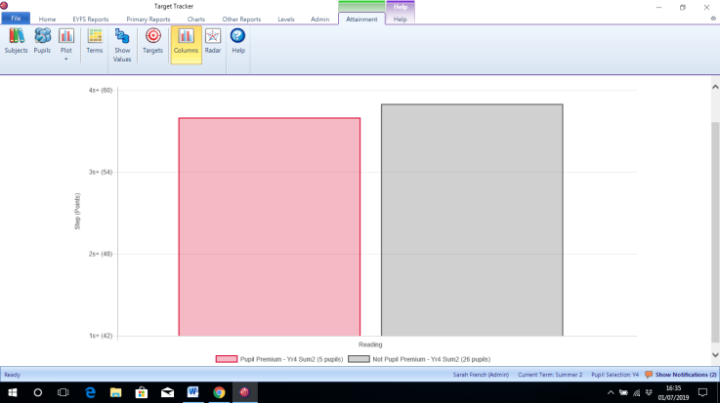
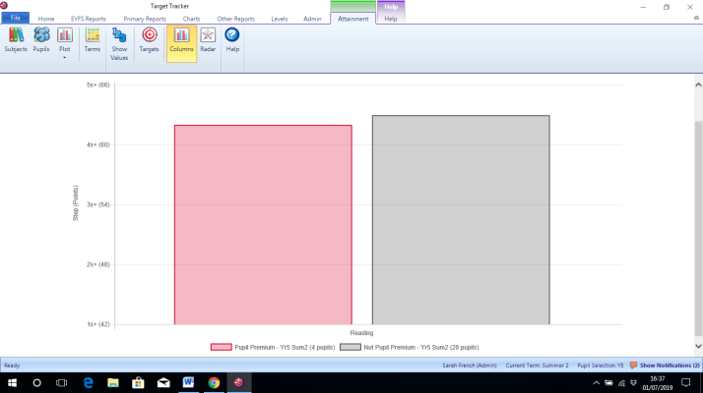
In 2 out 6 classes PP attainment in reading is higher than that of non PP children. In the other 4 classes, the attainment is nearing the same for PP as not PP.

AR reading has been consistently used throughout KS2 with clear progressive book banding in place in KS1.
Yoar 3
Yoar 2
Yoar 1

Yoar 6
Yoar 5
Yoar 4

Total Planned Expenditure:
c. 1-1 Intervention - Social
Desired outcome | Chosen action / approach | What is the evidence and rationale for this choice? | How will you ensure it is implemented well? | Staff lead
4b) Children will become more resilient, secure and confident. | - TIS-  A TA is trained in TIS and supports pupils with their social, emotional, behavioural needs and issues that have occurred at home that might have a negative effect on the learning day. Pupils receive a weekly session, or an individual session based on family circumstances. Advice from outside agencies can be obtained if needed. | TIS helps adults prepare children and young people for life’s emotional ups and downs.  The Approach teaches you how to be, and what to do, with children’s differing and sometimes challenging behaviour. As a result, children become more self-assured and ready to engage with life and learning.  Based on neuroscience and attachment research, Thrive training provides a targeted intervention.  Social and emotional learning: +4 mths Meta cognition and self regulation: +8 mths Behaviour interventions: +3mths | The SENCO supports teachers in identifying pupils for weekly support and works with the parents to discuss next steps at school and at home. Children will be screened and a clear baseline established. For targeted children an action plan will be devised which will be monitored regularly for impact. | JS/SF/  VW (TIS practitioner when trained)
Outcomes of review:
Although TIS training has been on-going for a TA (VW) this has not been put into practice yet due to the fact that training has only recently been completed and due to other demands on the TA’s time.
Total Planned Expenditure:
d. Group Intervention - Academic
Desired outcome | Chosen action / approach | What is the evidence and rationale for this choice? | How will you ensure it is implemented well? | Staff lead
4a)  The attainment in reading for PP pupils will rise to be in line with the attainment of all children. | PPG (TAs)  Accelerated Reader | This arrangement enables the  teacher to focus exclusively on a  small number of learners, usually on  their own in a separate classroom or working  area. Intensive tuition in small groups is often  provided to support lower attaining learners  or those who are falling behind, but it can  also be used as a more general strategy to  ensure effective progress, or to teach  challenging topics or skills.  Pupils selected are those that do not read at  home or those behind their peers, that require  additional support to increase their attainment.  EE Foundation Toolkit Reading comprehension strategies: +5 mths  Small group tuition: +4mths  Feedback: +8mths  Reading comprehension strategies: +5 mths | Teachers/teaching assistants keep records of who reads every day and their reading progress/AR quizzes. Also, progress discussed at termly pupil progress meetings. | JS/SF
4a, 4b, 4d | Speech and language support for pupils in EYFS and Year 1, who are under the care of the county speech and language therapists. | A significant number of pupils entering EYFS have poor speech and language and are below expectations in the communication and understanding areas of the curriculum. EE Foundation Toolkit  Early years intervention: +5 mths Communication and language approaches(EYFS): +6 mths  Oral language intervention: +5 | Therapists visit the pupils and the school’s support staff working with them each term, to assess progress and update provision and support. | SF
4a, 4b | Timely, daily focused interventions are run by support staff, for pupils identified as falling behind their peers or not making sufficient progress in an area of the curriculum. Also for those pupils identified as making rapid progress and requiring additional challenge in their learning. Interventions are focussed on specific learning objectives, speech and language needs or the working memory. | There are specific curriculum objectives that are not being achieved that are common to groups of pupils and can be targeted, to bring attainment closer to age related expectations.  EE Foundation Toolkit  Small group tuition: +4 mths  Feedback: +8 mths  Mastery learning: +5 mths  Oral language skills: +5 mths  Phonics: +4 mths | Senco/SLT regularly meet with support  staff and teachers to ensure  interventions are in place and appropriate.  Impact is discussed at termly  pupil progress meetings with  tracking of data.
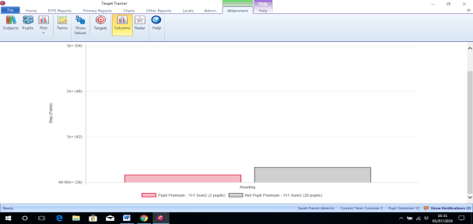
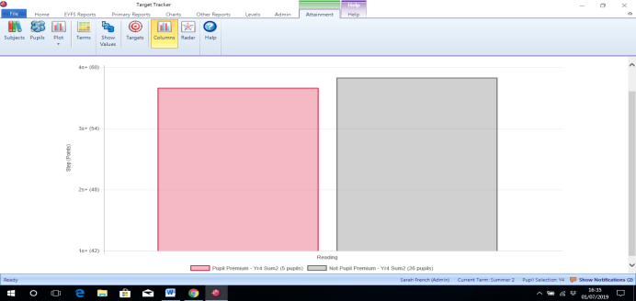
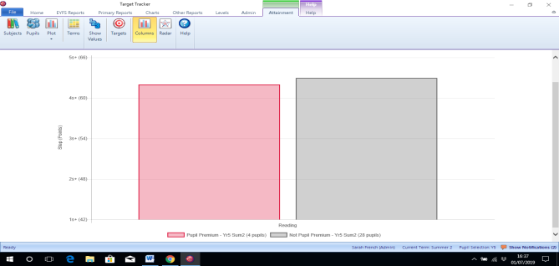
Outcomes of Review:
Yoar 3
In 2 out 6 classes PP attainment in reading is higher than that of non PP children. In the other 4 classes, the attainment is nearing the same for PP as not PP.

AR reading has been consistently used throughout KS2 with clear progressive book banding in place in KS1.

Yoar 2
Yoar 1

Yoar 6
Yoar 5
Yoar 4

The SALT team have signed off all but one of our EYFS and KS1 children and all none of our PP children are currently receiving support. The class TAs and teachers work hard to support the work of the SALT team within class time by following/using suggested intervention and support materials. This successful partnership has resulted in excellent progress of our pupils.

Interventions where possible have been actioned this year, and the results have been positive. However, teachers and TAs were at a disadvantage due to lack of staff available as a result of budget cuts and the need to support individual pupils on a 1:1 basis as opposed to supporting groups.
Total Planned Expenditure: |  |  |  | £
e. Group Intervention - Social
Desired outcome | Chosen action / approach | What is the evidence and rationale for this choice? | How will you ensure it is implemented well? | Staff lead
4d)  Children will become more resilient, secure and confident. | - Socially Speaking  - Time to talk  - Verbal feedback over written marking. | Oral language interventions emphasise the importance of spoken language and verbal interaction in the classroom. Oral language interventions therefore have some similarity to approaches based on Meta-Cognition, which make talk about learning explicit in classrooms and to Collaborative Learning approaches, which promote pupils’ talk and interaction in groups. Studies of oral language interventions consistently show positive benefits on learning, including oral language skills and reading comprehension.  EE Foundation Toolkit  Oral language intervention: +5mths  Meta-cognition and self-regulation +8mths  Feedback: +8 mths | Learning Walks, Performance management, Monitoring of planning and assessment data. The progress in steps of all children will be closely tracked.  Records of pupil conferencing will be kept and used to inform future planning for the teacher.  Termly monitoring of books and pupil conferencing will show progress for targeted children in each class. | JS/SLT/  Class teachers
Outcomes of Review:

Interventions where possible have been actioned this year, and the results have been positive. However, teachers and TAs were at a disadvantage due to lack of staff available as a result of budget cuts and the need to support individual pupils on a 1:1 basis as opposed to supporting groups.

Verbal feedback has had a positive impact as reported by students during pupil conferencing, “I like it when my teacher gives me verbal feedback because I can ask questions if I don’t understand and make improvements straight away.”
Some children still prefer some written marking, “I like written marking because I can go back and read it again to remind myself what my teacher said.”

Total Planned Expenditure: |  |  |  | £
f. Learning Resources
Desired outcome | Chosen action / approach | What is the evidence and rationale for this choice? | How will you ensure it is implemented well? | Staff lead
4d)  Children will become more resilient, secure and confident. | - TA support  - TIS  - Meta- cognition- solo taxonomy, growth mind-set- ½ hour weekly P4C lesson  - RM Easimaths | The intention is often to give pupils a repertoire of strategies to choose from during learning activities. The evidence indicates that teaching these strategies can be particularly effective for low achieving and older pupils. “Scaffolding” provides a useful metaphor: a teacher would provide support when first introducing a pupil to a concept, then reduce the support to ensure that the pupil continues to manage their learning autonomously. In 2015, evaluations of an intervention based on “Growth Mindsets” research, Philosophy for Children, and a programme called Thinking, Doing, Talking Science found gains of between two and five additional months’ progress.  EE Foundation Toolkit  Meta-cognition and self-regulation +8 mths  Oral language skills: +5 mths | Development of teaching approaches which encourage learners to plan, monitor and evaluate their learning.  Learning walks. | JS/SF/VW/ LAS/Class teachers
Outcomes of Review:
Although TIS training has been on-going for a TA (VW) this has not been put into practice yet due to the fact that training has only recently been completed and due to other demands on the TA’s time.

Both Assistant Headteachers attended CAST metacognition training with Lorwyn Randall. This resulted in the development and use across the school of the “Learn-o-saurs”. All children are able to access these and use them frequently when referring to their work, methods and learning behaviours. The AHTs have been trialling a new planning format to help them focus on the seven areas of metacognition to best support, remind and challenge all learners. They have reported that this format has been really helpful to focus activities and develop new ways of working-especially to develop children’s skills of memorising. The use of testing partners, jotting on post it notes and mind maps have all been positive. The AHTs have also been piloting the use of WIND (what I need to do), WING (what I need to get) and WINK (what I need to know) to encourage the children to be able to help themselves and become more independent learners. The children are noticeably saying “that’s a WIND” or, “Can I write that as a WINK?”
3 other CAST schools have taken planning ideas, WIND, WING and WINK and Learn-o-saurs to use at their schools. Two visiting Headteachers visited the school to discuss and take ideas for implementing Meta-Cognition in schools. The feedback that they were impressed by the learning behaviours witnessed and all children’s ability to explain their learning.
Children can be heard across the school discussing what learn-o-saur they are and are actively choosing to use modelled strategies to support their independent learning.

Total Planned Expenditure: |  |  |  | £
g. Staff Training
Desired outcome | Chosen action / approach | What is the evidence and rationale for this choice? | How will you ensure it is implemented well? | Staff lead
4d)  Children will become more resilient, secure and confident with consistent Quality First Teaching. | - Meta- cognition- solo taxonomy, growth mind-set. One half hour weekly P4C lesson in all classes. | The intention is often to give pupils a repertoire of strategies to choose from during learning activities. The evidence indicates that teaching these strategies can be particularly effective for low achieving and older pupils. “Scaffolding” provides a useful metaphor: a teacher would provide support when first introducing a pupil to a concept, then reduce the support to ensure that the pupil continues to manage their learning autonomously. In 2015, evaluations of an intervention based on “Growth Mindsets” research, Philosophy for Children, and a programme called Thinking, Doing, Talking Science found gains of between two and five additional months’ progress.  EE Foundation Toolkit  Meta-cognition and self-regulation +8mths | Training for staff on developments in Meta-cognition and solo-taxonomy. Continued use of Blooms Taxonomy.  CPD impact analyses will show an increase in staff confidence and expertise. | JS/SF/AB/  LAS/  Class teachers
Outcomes of Review:
Both Assistant Headteachers attended CAST metacognition training with Lorwyn Randall. This resulted in the development and use across the school of the “Learn-o-saurs”. All children are able to access these and use them frequently when referring to their work, methods and learning behaviours. The AHTs have been trialling a new planning format to help them focus on the seven areas of metacognition to best support, remind and challenge all learners. They have reported that this format has been really helpful to focus activities and develop new ways of working-especially to develop children’s skills of memorising. The use of testing partners, jotting on post it notes and mind maps have all been positive. The AHTs have also been piloting the use of WIND (what I need to do), WING (what I need to get) and WINK (what I need to know) to encourage the children to be able to help themselves and become more independent learners. The children are noticeably saying “that’s a WIND” or “can I write that as a WINK?” 3 other CAST schools have taken planning ideas, WIND, WING and WINK and Learn-o-saurs to use at their schools. Two Headteachers visited the school to discuss and take ideas for implementing Meta-Cognition in schools.
Children can be heard across the school discussing what learn-o-saur they are and are actively choosing to use modelled strategies to support their independent learning.

3-way learning has again enabled teachers to precisely differentiate to teach to exactly meet the needs of each group. The small groups means that teachers are able to be reactive and continually assess the learning of this group of learners as the lessons progresses. Misconceptions are picked up quickly and acted on immediately benefitting all groups of learners.
Total Planned Expenditure:
h. Enrichment/Raising Aspirations
Desired outcome | Chosen action / approach | What is the evidence and rationale for this choice? | How will you ensure it is implemented well? | Staff lead
4d)  Children will become more resilient, secure and confident. | - Cultural Capital | Cultural Capital can be defined as the skills and knowledge which an individual can draw on to give them an advantage in social life. The middle class places much more value on the following kinds of activities, and thus these are the kinds of activities which middle class children are more likely to be exposed to compared to working class children:  - Reading non-fiction and classical literature rather than pop literature  - Watching documentaries rather than soap operas  - Learning to play classical instruments (e.g. The Piano)  - Going on educational visits – to museums and art galleries for example  - Going on holidays abroad (to ‘broaden horizons’).  Exposure to the above activities provides middle class children with ‘cultural capital’ – many of the above activities are inherently educational in nature and provide middle class children with skills and knowledge which give them an advantage at school. This knowledge can either be specific – such as with reading non-fiction, or more general – such as cultural trips providing children with a sense of independence and self-confidence.  EE Foundation Toolkit Meta cognition and selfregulation: +8 mths | Topic plans have been updated to ensure/highlight Cultural Capital opportunities. Learning Walks, Performance management and monitoring of planning. | JS/SLT/LAS
Outcomes of Review:
Both Assistant Headteachers attended CAST metacognition training with Lorwyn Randall. This resulted in the development and use across the school of the “Learn-o-saurs”. All children are able to access these and use them frequently when referring to their work, methods and learning behaviours. The AHTs have been trialling a new planning format to help them focus on the seven areas of metacognition to best support, remind and challenge all learners. They have reported that this format has been really helpful to focus activities and develop new ways of working-especially to develop children’s skills of memorising. The use of testing partners, jotting on post it notes and mind maps have all been positive. The AHTs have also been piloting the use of WIND (what I need to do), WING (what I need to get) and WINK (what I need to know) to encourage the children to be able to help themselves and become more independent learners. The children are noticeably saying “that’s a WIND” or “can I write that as a WINK?” 3 other CAST schools have taken planning ideas, WIND, WING and WINK and Learn-o-saurs to use at their schools. Two Headteachers visited the school to discuss and take ideas for implementing Meta-Cognition in schools.
Children can be heard across the school discussing what learn-o-saur they are and are actively choosing to use modelled strategies to support their independent learning. The students are able to decide the resources that will help them with their learning and help them to move forward.

Total Planned Expenditure: |  |  |  | £
i. Home Support (e.g. breakfast club, EWO etc.)
Desired outcome | Chosen action / approach | What is the evidence and rationale for this choice? | How will you ensure it is implemented well? | Staff lead
4c)  Increased attendance for PP pupils. | - EWO  - Rewards  - Newsletter  - Attendance clinic  The purchasing of the Education  Welfare Service package, to  support the school in lowering  the persistent absence rate.  Includes attendance clinics, late  gates and home visits. | Persistent absence is a serious problem. Much of the work children miss when they are off school is never made up, leaving them at a considerable disadvantage to their peers. There is clear evidence of a link between poor attendance at school and low levels of achievement:  - Of pupils who miss more than 50% of school, only 3% manage to achieve five A* to Cs, including English and maths  - Of pupils who miss between 10% and 20% of school, only 35% manage to achieve five A* to C GCSEs, including English and maths  - Of pupils who miss less than 5% of school, 73% achieve 5 A* to Cs, including English and maths  In 2012, the DfE published a report on 'Improving attendance at school', carried out by Charlie Taylor. The report says on page 4 that there is a clear link between poor attendance at school and lower academic achievement.  EE Foundation Toolkit  Parental involvement: +3 mths | Tracking of attendance in targeted children. Evaluations and reports from outside agencies. | JS/SLT
4b, 4c, 4d | An interpreter is booked for meetings where a parent’s first language is not English. | Every year group has pupils whose parents do not speak English.  EE Foundation Toolkit  EE Foundation Toolkit  Parental involvement: +3 mths | Teachers liaise with the office staff, to book interpreters for all meetings. | SC/CP
Outcomes of Review:

Attendance for PP children is not an issue at St Mary’s.
In Y6 the rate of attendance for PP children is 1.5% higher than that of children who are not PP.
In Y5 the rate of attendance for PP children is just 0.2% lower than that of children who are not PP.
In Y4 the rate of attendance for PP children is higher and stands at 6.6% lower than that of children who are not PP but this is due to one child with serious emotional and neuro needs who has had much time off directed by medical professionals.
In Y3 the rate of attendance for PP children is just 0.5% lower than that of children who are not PP.
In Y2 the rate of attendance for PP children is 1.5% higher than that of children who are not PP.
In Y1 the rate of attendance for PP children is 1.7% higher than that of children who are not PP.
In Reception the rate of attendance for PP children is 4.8% higher than that of children who are not PP.
PP attendance for the whole school 96.8% which is slightly higher than that of non PP children- 96.4%

Parents who do not have English as a first language are always offered an interpreter for meetings- most decline- but the option is always available.

Total Planned Expenditure:

- Additional detail
This strategy will be subject to ongoing monitoring throughout the year. Changes will be made dependent on the needs of individual children and cohorts as deemed necessary.

