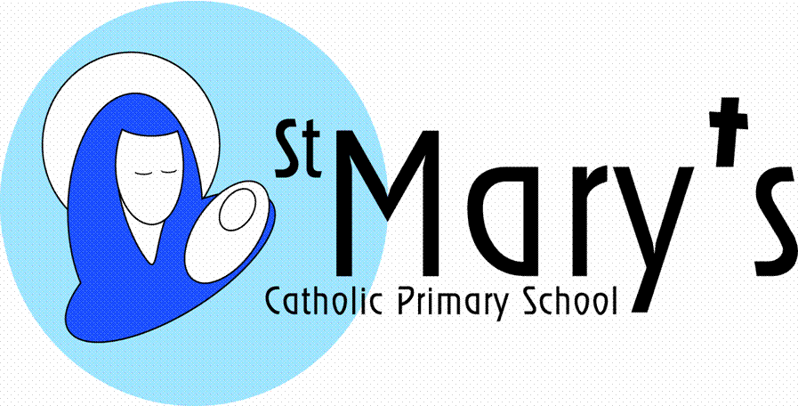

# Newsletter Issue 9: 11th January 2019

Dear Parents,

I hope you enjoyed a good Christmas and New Year with family and friends.

I would like to inform you that I will be retiring from my post of Headteacher here at St Mary’s at the end of this academic year in July. I joined this wonderful school in September 1996 as Deputy Head, was lucky enough to be appointed Headteacher in April 2004 and feel privileged and proud to have worked here for the past twenty two years. For many reasons I now feel the time is right to hand over the reins to someone new (and no doubt younger!)

Plymouth CAST, our Multi Academy Trust will now be responsible for appointing a new leader and hopefully with early notification of my retirement, they will have plenty of time to secure the appointment of the future leader for our school.

In the meantime, it is business as usual, so please do ensure you check the fortnightly newsletter for all the news, upcoming events and activities which are planned this term.

Warm regards Jacqui Scarborough

**Are you able to help?**

We’re looking for volunteers;

* to hear readers in class
* to help in the library
* on the ‘Walking Bus’
* to help with supervision on the swimming coach on a Friday
* to help with transportation to sporting events

If you are able to assist, please see Mrs Chapman or Mrs Pipkin in the School Office.

# C:\Users\jscarborough\AppData\Local\Microsoft\Windows\INetCache\IE\MR7SOQ26\volunteers-needed[1].png

# DIARY DATES

**January**

15th Brass tuition recommences

16th Gifted & Talented Masterclass at Falmouth School

Guitar tuition recommences

17th Drumming tuition commences

23rd Class 2 visit to Maritime Museum

27th Enrolment Mass - St Mary’s Catholic Church @ 10.45am

31st Assembly - Mary’s Meals

**February**

4th  Class 1 hearing re-tests

11th Assembly and workshops - NSPCC

**March**

6th Ash Wednesday Mass

7th Class 3 Fairtrade Coffee Morning from 9.45-11.15am

28th Songfest for Class 6 @ Falmouth Methodist Church

28-29th Class 5 residential to Carnyorth

**STARTING PRIMARY SCHOOL- LAST CALL!**

**At least one family over the past 3 years has been disappointed that their child has not got a place because they didn’t submit the online application or supplementary form for admission before the deadline of the 23:59 on 15th January. Please remember if you are applying for a place at St Mary’s School you must complete a supplementary form (as well as the Local Authority application form) which can be obtained from the School Office or our website www.st-marys-fal.cornwall.sch.uk**

If you have a child born between 1st September 2014 and 31st August 2015 then they are due to start school in September 2019. **The deadline for applications is 23:59 on 15th January 2019.** You can apply online at [www.cornwall.gov.uk/admissions](http://www.cornwall.gov.uk/admissions).

**SPORTING NEWS**

Falmouth Basketball League starts on Wednesday 30th January.

Falmouth and Penryn Cross-country Races for Years 4-6 take place on 25th January.

Cross-country finals take place on 12th February with the County finals on 12th March.

**AFTER SCHOOL CLUBS**

Please note clubs commence week beginning **Monday 14th January**, unless otherwise stated on the list that was sent home on Wednesday. Please complete the permission slip if your child would like to attend a club and return to the school office.

Go Active clubs – Dodgeball commences on Monday 14th January/KS1 & KS2 Multi-skills start during week commencing 21st January. There is still availability in all Go Active clubs.

**ENROLMENT MASS**

On **Sunday 27th January 2019** we will be enrolling the children who will be making their First Holy Communion this year. This will be a whole school celebration and we would like to see as many of our pupils representing the school at the **10:45am** Mass at St Mary’s Catholic Church on Killigrew Street. Our pupils will be taking an active part and this invitation is extended to all. The choir will also be taking part, so we hope that as many as possible will come along.

**RAFFLE PRIZE**

Tony Eyles won a raffle prize at the FOSMs Christmas Fayre. Unfortunately the contact details on the winning ticket are not clear, so if this person is known to you please can you contact the School Office.

|  |  |
| --- | --- |
| **Captain’s Table** | **Class 2** |
| St Mary’s Super Stars  MC900432616[1] | Isla D  Georgia  Farren  Callum  Charlie R  Ethan W  Grace |

**FOUND IN AND AROUND THE SCHOOL**

Child’s reading glasses (black with blue trim)

Fitbit

Child’s Rudolph Christmas jumper (Next - age 7 years)

Child’s short sleeved white shirt (age 9 years)

**CHRISTMAS DONATIONS TO THE FOODBANK** 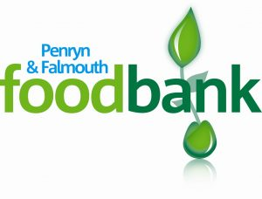

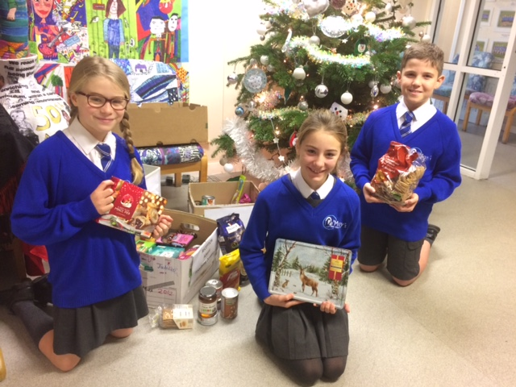

A big thank you to all who contributed food items for the Penryn and Falmouth Foodbank.

Items included: Mince Pies, Christmas cakes, biscuits and other Christmas treats.

Mr Pipkin delivered the goods at the end of term to a very grateful team of volunteers.

**COMMUNITY EVENTS**

**MESSY CHURCH** is an all-age **family** gathering with craft, games, songs, story and food, not like conventional church; that is partly why it’s called “Messy”. There is plenty of space for the energetic to run around, and we do not expect anyone to sit quietly when they are not in the mood.

The next gathering will be on **SATURDAY 12th January between 9.30 and 11.00 at All Saints Church, Killigrew Street, Falmouth**. We will start at 9.30 with a healthy and delicious **breakfast** and then there will be games and activities, followed by an interactive story and songs. Everyone is welcome and **we would be delighted to see you**. All children must be accompanied by an adult please.

Messy Church is free, but donations are very welcome.

**The Princess Pavilion** is about to stage a wonderful family theatre production.

“The Sea Show” is to be performed by the brilliant Squashbox Theatre and will take place on Saturday 16th February at 2:30pm!

This show is perfect for ages 4+ and their families.  It is approximately 50 minutes long and will involve puppetry, storytelling, natural history education and music!  Please see the link below with more information:

<https://www.squashboxtheatre.co.uk/the-sea-show>

*Please note that signposting to any activities/services by St Mary’s School does not constitute an endorsement or recommendation. It is recommended that parents/carers make their own enquiries to satisfy themselves as to the suitability of these. Under no circumstances will either St Mary’s School or Plymouth CAST accept responsibility or liability for any such activities/services*

**MUSIC PROVISION - Spring Term 2019**

The music provision, supplied by Cornwall Music Service Trust for St Mary’s School commences: March for Classes Reception and One

January for Classes 2, 3 and 4

This term for Class 5 (start date to be confirmed)



**SCHOOL BANK**

The bank is open for customers on a Tuesday morning from 8.45am and is located in the library. Mrs Higham and the Year 6’s run the bank on a weekly basis. Every child at St Mary’s has a bank account, so please encourage your child/ren to visit the bank to pay for school trips or save small amounts for future personal use. Withdrawals are available most weeks.

Parents are also encouraged to visit the bank should they wish to check on their child’s bank balance.

