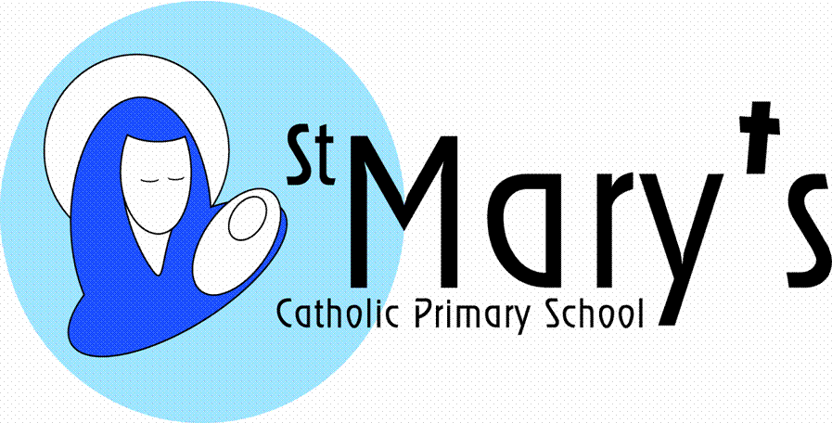

**Year 6**

**Summer Term**

**The Legacy of the Ancient Greeks**

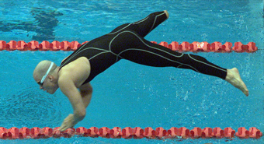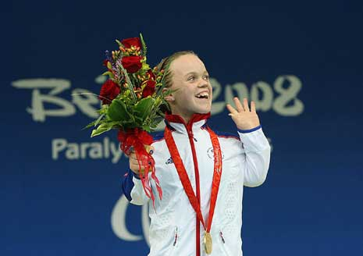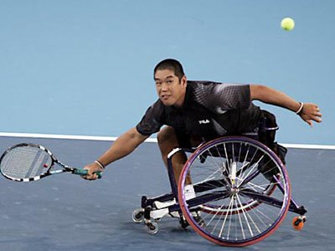

This topic has been designed to challenge stereotypes, to look at ways in which our world is divided and to explore solutions to bring it together. The initial focus will be on sport as a vehicle to bring people together. The children will look at worldwide sporting events and make studies of some of the nations represented, looking at cultural, religious and ethnic diversity. The history of sport will be investigated and focus made on the Ancient Greeks and the first Olympics. The next focus will be on the Paralympics with studies of people who have overcome disability to achieve great success. Next a look at healthy cereals and produce artwork from sporting poses. Science will involve learning all about the human body and how we keep it healthy.

|  |  |
| --- | --- |
| Literacy | The children will do lots of journalistic writing relating to sporting events – particularly the Ancient Greek Olympics and also formal writing conveying information about the Ancient Greeks and different sports. From Ancient Greece the children recreate classic myths and legends. Biography writing of famous paralympians will also be included. |
| Maths | Every term the children will cover a variety of maths objectives related to five main areas:  Counting, partitioning and calculating  Securing number facts and understanding shape  Handling data and measures  Calculating and measuring  Reasoning and applying mathematical ideas. |
| Science | All aspects of the human body, how it works, how it stays healthy and how it changes will be covered in this topic. In addition healthy and balanced diets are revised. This will include work on microorganisms and vaccinations. |
| History | The children will study the Ancient Greek civilization and the start of the Olympic games. They will compare and contrast the ancient and modern Olympics. |
| Geography | The geography for this topic will stem from the sporting nations taking part in events like the Olympic games, World Cup, Commonwealth Games, World Championships (dependant on the year). Many of these nations will be researched by the children, establishing key demographic data. They will use this data to compare and contrast the demography of the UK and Cornwall. |
| Art | In this part of the topic the children will be doing close observational drawings of sporting poses. They will also study Greek art on coins, plates and vases and recreate their own canvas paintings using these designs. |
| DT | The children will be researching different types of cereals and what they promote. They then design and make their own healthy cereal box. |
| ICT | The children will use data logging ICT equipment to carry out pulse and temperature tests. They will use ICT to research and present their findings on Olympic nations and inspirational sportsmen and women. As part of the preparations for school camp they will set up spreadsheets to work out food costs. The children will undertake indepth research on cereals and their ingredients. They will create a stop frame animation of a chosen sport using the IMotion HD on the Ipads.  Throughout the topic digital literacy (e-safety) skills will be developed. |
| Music | The children will listen to inspirational music linked to sporting endeavours and also music and dances linked to Greece. They will create their own compositions which reflect a race or a sporting event. |
| PSHE | This topic is all about PSHE and Citizenship; appreciating everyone for who they are as unique individuals and understanding how they can stay healthy and work together. Exploding stereotypes, banishing racism and other discriminatory behaviour and valuing everyone’s religious and cultural identity are all at the heart of bringing the world together. School camp will be a superb environment for team work, working together to achieve personal goals. |
| Homework | Children are expected to read EVERY night. They are now expected to know their times tables up to 10X – if they don’t they must continue to practise. They will have spellings and two other subjects on Mondays to be returned by Friday. |
| British Values | The children will learn about the key Olympic values and how they link to our British Values. They will also explore the importance of equality and difference.  Mutual respect and tolerance of other faiths and beliefs are taught in our RE topics. |
| Safeguarding | Children will look at the dangers of drugs and the problems that drugs cause in society and in sport. |
| Pupil Premium  Cultural Capital | Children will:   * Paddle in the sea * Go on an outdoor residential * Learn from failure |