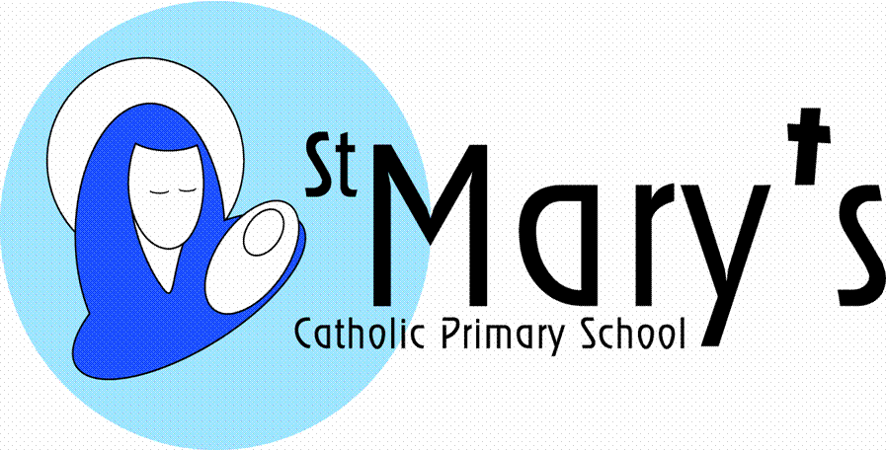

NEWSLETTER ISSUE 3: 5th October 2018
Dear Parents,
In the current climate of school budget cuts, all fund raising efforts by our hardworking FOSMs (Friends of St Mary’s School) are even more important. If you can help in any way please come along to the next FOSMs meeting on the 11th October at 3:30pm in the school hall.
Once again at the beginning of the school year, I would like to remind parents of the importance of listening to your child read daily and also helping them to learn their multiplication tables and number bonds. They need to be able to recall these number facts using instant recall and need plenty of practice in doing so. Daily reading at home makes a massive difference to outcomes at the end of the year. Many thanks in advance for all your support and help with these homework activities.
Finally, please don’t hesitate to speak to me at the gate in the mornings if you have any queries, concerns or just for a chat!
Warm regards
Jacqui Scarborough

DIARY DATES
October
9th Class 2 celebrations @ 9:15am
10th Class 6 visit to The Eden Project
Class 3 visit Trenance Chocolate Factory
11th Tempest Photographs – individual and family groups from 8.20am in the hall
15th Class 4 visit to Queen Mary Gardens
Apostleship of the Sea Assembly @ 9:10pm
16th Reception - Y5 Flu vaccinations
17th Class 1 Celebration @ 9:15am
19th INSET Day – School Closed to Pupils

November
1st Class 4 visit to Lanhydrock House
25th ‘Christ the King’ Parish School Mass @ St Mary’s Church, Killigrew @ 10:45am

December
W/B 3rd Prayer Space
6th Hearing Tests Class 1
7th Choir to visit Stroke Club
14th Choir Performance with Truro Male Voice Choir @ 6:00pm
20th End of Term Mass @ 9:15am

LEGO THERAPY
We are keen to introduce an intervention group called "Lego therapy". Brick building play therapy can results in better communication skills for children. This specific type of play therapy can also improve children’s abilities to change their behaviour, understand and talk about their feelings, solve problems and learn about the world in which they live.
For this group to work we really need the donation of:
- brick building base plates
- Lego/brick figures
- Small/medium complete sets of Lego (or alternative makes), instructions are required.
Any donations are gratefully received.

ADMISSIONS
If you have a child born between 1 September 2014 and 31st August 2015 then you will need to apply for your child’s Reception 2019 place by Tuesday 15th January. For information and guidance please visit www.cornwall.gov.uk/admissions where you will also find the application form. Email: schooladmissions@cornwallgov.uk Telephone: 0300 1234 101. For any help with your application, please contact the Family Information Service on 0800 587 8191. The National Offer date is 16 April 2019; this is when you will be notified of your allocation.
Important Note – a Supplementary Form is also required for places at St Mary’s School. This is obtainable from the School Office or on our website.

Transfer to Secondary School
Don’t forget! Is your child currently in year six at primary school? If so, you will need to apply for a place in year seven at a secondary school for September 2019. The deadline for applications is 31 October 2018 which is fast approaching.

ATTENDANCE REMINDER
Leave of Absence requests.
As we begin the new academic year, we respectfully remind parents of the following;-
- Leave of absence will only be authorised in extenuating circumstances
- Reasons relating to financial advantages for example will not be authorised.
- If the permission to take leave is not granted and the pupil still goes on holiday, the absence will be unauthorised and referred to the Education Welfare Officer as to whether further action is required.

BREAKFAST CLUB
The Club runs from 8:00am until 8:45am. A selection of cereals, toast and various spreads and jams as well as fruit and yogurt will be available. The breakfast sessions are supervised by Mrs Alway (lunchtime supervisor) and Mrs Slater. The cost is £2:50 per session but if uptake increases, we’re hoping to reduce the daily cost.
Healthy breakfasts benefit pupils by improving their concentration, behaviour, attendance, punctuality and educational attainment. Research funded by the Education Endowment Foundation found that pupils who enjoyed a nutritious breakfast, boosted their reading, writing and maths by an average of 2 months’ progress per year.

WALKING BUS
The ‘Walking Bus’ leaves the Co-Op at the bottom of Mongleath Rd at 8:30am to walk the short distance to school. This relieves congestion in the cul-de-sac and also gives a healthy start to the day for the children. To enroll, please collect a form from the school office. If you are able to assist, even if only for one morning a week, please let us know.

SCHOOL COUNCIL CLASS REPRESENTATIVES
Congratulations to our new class representatives who were voted by their classmates after presenting their magnificent manifestos. They’ve already participated in their first School Council Meeting.
Class 1 - Phoebe and Owen
Class 2 - Zephyr and George H.
Class 3 - Millie and Carsten
Class 4 - Mollie and Spencer
Class 5 - Ava-Rose and Mawgan
Class 6 - Lola T., Rosie, Chloe, Thomas P., Charlie, Lewis

VOLUNTEER TO HELP ON THE SWIMMING BUS
We desperately need a volunteer to help on the swimming bus on a Friday at 12.30pm.
Please let the School Office know if you can help out.

PLYMOUTH CAST -VISION & VALUES CONSULTATION
An opportunity to have your say on the vision, mission, values, principles and behaviours which will bring about a step change in the quality of education in CAST schools, inspired by the Gospel and the teaching of the Catholic Church.
Raymond Friel, the recently appointed Chief Executive Officer of our multi academy trust Plymouth CAST, is consulting with all stakeholders (parents, staff, pupils and governors) to contribute to a new Vision and Mission Statement. A PowerPoint which includes the key information and questions are available on our school website to any parents who would like to contribute. Please return any responses in writing and submit to the school office by 11th October.
Click on the link to access the vision and values consultation page on the school website.
http://www.st-marys-fal.cornwall.sch.uk/web/vision_and_values_consultation/372068

SPORTING NEWS
Competitive League
St Mary’s v St Francis 3-3.
Training League
St Mary’s v St Francis 1-0
Congratulations to both teams for a great start to the netball season!
HARVEST
Many thanks for all the Foodbank offerings which were presented at our Harvest Mass this morning. Mr Pipkin will be delivering the food to the Foodbank on Tuesday 9th October, so if you haven’t had chance to contribute, please bring your offerings in by then.

TWO MIDDAY SUPERVISOR VACANCIES
About the roles
We have two vacancies for Midday Supervisors to join our dynamic
Lunchtime team.
One of the positions is 1:1 to a child with special educational needs.

Hours: 6.25 hours per week – 11:45am - 1pm
Fixed Term position for initially 2 terms, term time only
Start date: As soon as possible.

We are looking for supervisors who will ensure the smooth running of the canteen meals, packed lunches and the supervision of children at play. Successful candidates will support school behaviour management by supervising areas of the school during lunchtimes and encouraging pupils to behave in a healthy, safe and considerate manner.
We are committed to safeguarding and promoting the welfare of children and all applicants will be required to obtain an enhanced Disclosure and Barring Service check.

Application pack: Available from the School Office.
Closing date: 15th October 2018
Interview: TBC

SOUTH WEST CELEBRATE WEEKEND
A joyful and faith-filled event for all the family!
13th/14th October
Notre Dame School, Looseleigh Lane, Plymouth PL6 5HN

Main Speakers: Maria Heath, Fr. Oscar Ardila, Charles Whitehead
Separate streams for children & young people
Lively worship, drama, a variety of workshops, family Mass
……………………………………….
Online booking now open (Prior booking essential)
More details: www.celebrateconference.org
Email: southwest@celebrateconference.org
Rebecca 01395 489902
Or Susanne 01803 606256
(Poster Erratum: 16 -22 Conference Fee should read: £15)

Please note that signposting to any activities/services by St Mary’s School does not constitute an endorsement or recommendation. It is recommended that parents/carers make their own enquiries to satisfy themselves as to the suitability of these. Under no circumstances will either St Mary’s School or Plymouth CAST accept responsibility or liability for any such activities/services.

