
Year 5
Autumn Term

Invaders
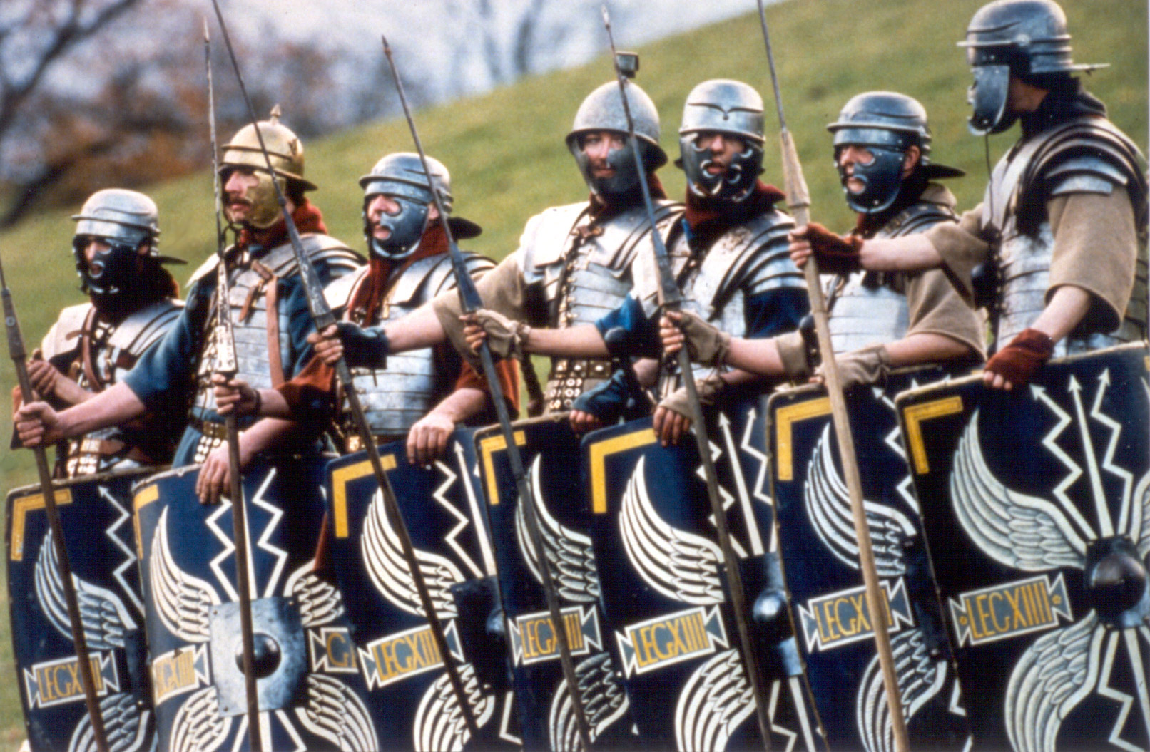

Through this topic the children will embark on a timeline journey to see the development in British history as various invaders attacked our shores. They will study a selection of Celts, Romans, Anglo Saxons and Vikings and through them get an understanding of where they came from and the cultural diversity of the British Isles. They will link this to their appreciation of cultural diversity today. The children will look at the influences of these invaders in and around Cornwall.

  Literacy | During the first half term the children study the Romans. They write a recount of Boudicca’s revolt as well as imagining they are Roman soldiers. They will create information texts about various aspects of Roman life, as well as writing instructions for how to be build a Roman road or a sewer. On the fiction side narrative myths of Romulus and Remus are produced.  During the second half term the children write a quest based on King Arthur and the Knights of the Round Table. They will also write an account of a Viking invasion and instructions.
  Maths | Every term the children will cover a variety of maths objectives related to seven main areas:  - Number and place value  - Addition and subtraction  - Multiplication and division  - Fractions  - Measurement  - Geometry  - Statistics
  Science | Children will be looking closely at the properties of materials in order to durable Roman shields. They will be testing materials for various properties. They will also be looking at forces, especially related to floating and sinking and also forces involved in Roman weaponry – onagers, mangonels and trebuchets. They will look at air resistance and gravity in relation to the flight paths of the Roman javelin (pilum).
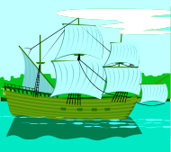  History | The children will be using primary and secondary sources of information to take a time line through history of the invaders – Celts, Romans, Anglo Saxons and Vikings. They will also consider present day invaders and make comparisons. They will research various aspects of Roman life to create information texts. They will also use a range of sources to understand life in different time periods and compare it to now.
  Geography | The children will use maps to see where the invaders came from and draw maps to show the extent of their invasions in Britain. They will focus on Italy and the Roman empire. They will also use smaller scale maps to identify Roman roads in Britain.
  Art | Children will create Roman-style sculptures using clay.
  DT | After investigating materials the children will design and make their own Roman Shields, large enough to form themselves in the tortoise formation. They will also be making catapults in science.
  ICT | Presentation is a key factor of this topic; the children will use Google and other resources to create their own book to convey key information about their learning of the different invaders. They will also use Garageband to enhance their work in music. Throughout the topic digital literacy (e-safety) skills will be developed.
  Music | The children will be using their imaginations and a variety of instruments to create and compose music to tell the story of an invasion.
  PSHE | Through looking at Invaders of the past and discussing modern invasions children will identify the characteristics of successful and peaceful societies.
  British Values | Children will learn about democracy and the rule of law through learning about the Roman democratic and legal systems. They will compare this to the political system in Britain.  Mutual respect and tolerance of other faiths and beliefs is covered through our RE lessons.
  Pupil Premium  Cultural Capital | Children will:  - Visit the Maritime Museum  - Go on a trip to a castle  They will also learn how to debate courteously and engage in debates about Roman laws.
  Safeguarding | Children will look at modern day invaders around the world and discuss how we stay safe from war and vigilant against terrorism.
  Homework | Children will be given spellings, grammar and Maths homework each week, in addition to a range of projects to support our English and topic work. Homework given on Friday to be returned to school by the following Friday.  Reading for 15 minutes daily. Reading books and record to be in school every day.

