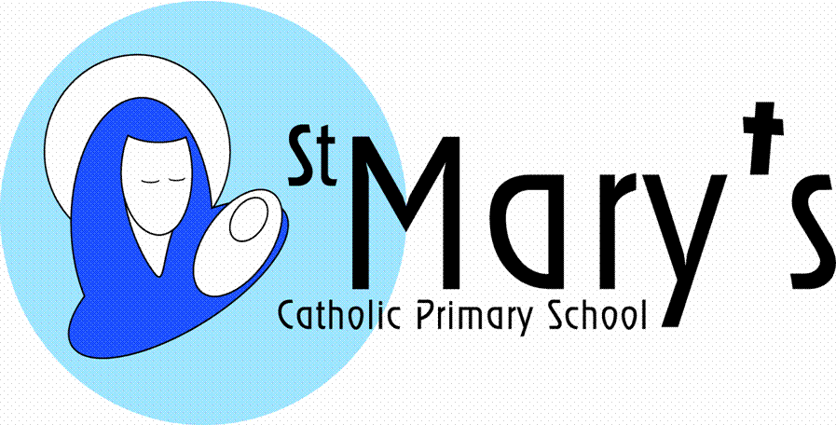
Relationship Education- Parent Consultation Survey Questions

Please return by email to: schapman@st-marys-fal.cornwall.sch.uk by Friday 10th July.

Name of parent(s)/carer
Name of child(ren) |  | Year Group(s)

Select an answer for each of the following questions. If you have any further comments to add, use the comment box beneath each question.

After reading the information in the Parent Consultation Tool about the content of ‘Life to the Full’:

I understand what my child will be taught and when.
Strongly agree Agree Undecided Disagree Strongly disagree
I am comfortable with the Catholic ethos of the programme.
Strongly agree Agree Undecided Disagree Strongly disagree
I trust my school’s judgment in delivering this programme.
Strongly agree Agree Undecided Disagree Strongly disagree
I feel that my child will need additional support in understanding some of this content.
Strongly agree Agree Undecided Disagree Strongly disagree
I understand and accept that my role is as the ‘first educator’ of my child on matters related to teaching human sexuality.
Strongly agree Agree Undecided Disagree Strongly disagree
I would value further support from school about how to talk to my child about sensitive issues.
Strongly agree Agree Undecided Disagree Strongly disagree
The option to teach some elements of the programme is left to the discretion of schools in consultation with parents. These areas are called ‘Key Decisions’ and cover the discussion of genitalia (KS1), puberty (LKS2) and sexual intimacy (UKS2).
I approve of my child learning the names of external genitalia in KS1.
Strongly agree Agree Undecided Disagree Strongly disagree
I think Year 4 is a good time to start learning about physical changes during puberty.
Strongly agree Agree Undecided Disagree Strongly disagree
I am happy for my child to be taught about sexual intimacy in Year 6, in a way that is respectful of Catholic beliefs.
Strongly agree Agree Undecided Disagree Strongly disagree
I think it is important that pornography is covered from an internet safety perspective.
Strongly agree Agree Undecided Disagree Strongly disagree
I think it is important that pornography is discussed as a way in which people are ‘used’.
Strongly agree Agree Undecided Disagree Strongly disagree
I would like further details regarding the optional content around these ‘Key Decisions’.
Strongly agree Agree Undecided Disagree Strongly disagree
In the box below, write any further comments or queries that you have:
COMMENT BOX

